A Practical Guide to .NET
DataTables, DataSets and DataGrids

Pete Smietana


BioXing™
201 Fieldcrest Ct.
Danville, CA 94506

Contributors

Greg Dunn
Wouter P. van Vugt

Original: December 22, 2003
Last Update: February 23, 2005

Version 1.02

Copyright © 2003 BioXing. All rights reserved.

Distribution Rights.
The contents of this document can be freely copied and disseminated with the condition that the document retains reference to BioXing, the author and its Copyright notice. In addition, the document or any part of the document cannot be incorporated into commercial products without prior permission of BioXing and its author. BioXing retains all rights to commercial use of this document.

Table of Contents

1 Introduction 6
2 Overview 6
3 DataTables 7
3.1 DataTable creation 8
3.2 Columns – Creating and Adding to Tables 9
3.3 Deleting/Removing Columns 12
3.4 Modifying Column Properties 12
3.5 Clearing Column Collection 12
3.6 Cloning a Table 12
3.7 Rows – creating and adding to a table. 13
3.8 Modifying data within an existing table row 15
3.9 Fill Table using LoadDataRow() method 16
3.10 Retrieving Table Content 16
3.11 Row Versions and Accepting/Rejecting Changes 17
3.11.1 Methods and Enumerations 17
3.11.2 Sample 1 – Row States 19
3.11.3 Sample 2 – Initial Loading of Table 20
3.11.4 Sample 3 – DataRow AcceptChanges 21
3.11.5 Sample 4 – Table AcceptChanges 22
3.11.6 Sample 5 – DataRow BeginEdit 23
3.11.7 Sample 6 – DataRow CancelEdit 24
3.11.8 Sample 7 – DataRow BeginEdit – Example 2 24
3.11.9 Sample 8 – DataRow Change values – Example 2 25
3.11.10 Sample 9 – DataRow EndEdit – Modified Rows 26
3.11.11 Sample 10 – DataRow AcceptChanges of Modified Rows 27
3.11.12 Sample 11 – DataRow RejectChanges 28
3.11.13 Sample 12 – LoadDataRow without table having primary key 28
3.11.14 Sample 13 – LoadDataRow with table having primary key 29
3.11.15 Sample Code for Obtaining Version and State Information 30
3.12 Sorting DataTable Rows 31
3.13 Handling DataTable Errors 32
3.14 DataTable Events 33
4 Data Sets 33
4.1 DataSet Methods 34
4.2 DataSet Properties 34
4.3 Loading A DataSet 35
4.3.1 From a Table 36
4.3.2 From a Database 36
4.4 Linked Tables 38
4.5 Linked tables in a dataset 40
4.5.1 Filling 40
4.5.2 Removing 41
4.6 XML Export and Import DataSet Data 41
4.6.1 WriteXml 41
4.6.2 ReadXml 41
4.7 Handling DataSet Errors 42
4.8 Updating Database with DataSet/DataTable changes 42
5 Data Grid 45
5.1 Methods and Properties 45
5.2 Assigning Data Sources 46
5.3 Formatting 47
5.3.1 DataGridTableStyle - WinForms 47
5.3.2 Change only one table’s DataGridTableStyles 48
5.3.3 Change a single column in a Table’s DataGridTableStyle 49
5.3.4 Create a DataGridTableStyle for Tables Based upon its Data 50
5.3.5 Defining DataGridTableStyles through Visual Studio .NET IDE 54
5.4 Navigation 56
5.4.1 CurrencyManager 56
5.4.2 CurrentCell 56
5.4.3 Selecting Rows 57
5.4.4 Expand and Collapse linked tables 57
5.5 Copy DataGrid to the Clipboard 58
5.5.1 Copy selected table in DataGrid to clipboard 59
5.5.2 Copy all tables in DataGrid to clipboard 59
5.5.3 Format table data into a string 60
5.6 Exporting to a Tabbed delimited Text File 61
5.7 Cloning Table contained in a DataGrid 63
5.8 Comparison of WinForms & WebForms 63
5.8.1 WinForms 64
5.8.2 WebForms 65
6 References 73
7 Appendix 74
7.1 Visual Basic.Net Code Example for FormatDG 74

Version History

Version | Author | Date | Description
1.00 | Pete Smietana | 10/17/03 | Initial Version
1.01 | Pete Smietana | 12/22/03 | Added Section 'Sorting DataTable Rows'
 | Greg Dunn | 12/24/03 | Contributed VB.Net version of formatDG() which was added to the Appendix.
 | Pete Smietana | 12/31/03 | Added more explanation and code examples for event handlers to the 'Updating Database with DataSet/DataTable Changes' section.
1.02 | Pete Smietana | 2/23/2005 | Robert Shih found error in section 3.6 where a column is renamed. When the column name changes; the new column name must be used in any further references to the column.

Contact Info

Name | Contact Information
Greg Dunn | Instinctive Webware & Database, iam@gregdunn.com , 925.918.1894
Pete Smietana | BioXing www.bioxing.com , psmietana@bioxing.com, 925.736.6329
Wouter P. van Vugt | http://wvanvugt.net , wouter@wvanvugt.net or wvanvugt@wvanvugt.net  Reference to Advanced DataGrid Sizing article: http://www.codeguru.com/cs_controls/AutoSizeDataGrid.html

Introduction
The purpose of this document is to provide a practical guide to using Microsoft’s .NET DataTables, DataSets and DataGrid. Most articles illustrate how to use the DataGrid when directly bound to tables within a database and even though this is an excellent way to use the DataGrid, it is also able to display and manage programmatically created and linked tables and datasets composed of these tables without being bound to a database. Microsoft’s implementation has provided a rich syntax for populating and accessing rows and their cells within tables, for managing collections of tables, columns, rows and table styles and for managing inserts, updates, deletes and events. Microsoft’s Visual Studio .NET development environment provides detailed explanations and code examples for the classes, which is excellent for obtaining a quick reference to a method or property, but not for understanding how they all fit together and are used in applications.
This article will present different ways to create and manage bound and unbound tables and datasets and to bind them to DataGrids for use by WebForms and WinForms. The different behaviors of the DataGrid depending upon whether it is in a WebForm or a WinForm will be presented. In addition, copying DataGrid content to the clipboard, importing and exporting in XML and printing will be presented. Techniques for linking DataGrid content to features within graphics objects to provide an interactive UI will be discussed in the last section.
The intent of this article is not to be a complete reference for all methods and members of the classes used for building Tables, Datasets and DataGrids, but to illustrate systematically how to build and manage them using their essential methods and properties. The article will also show equivalent ways for working with these entities to illustrate programming flexibility options. Once they are built the tables can be added to a database and/or the content easily extracted for updating existing database tables.
The structure and features of a table created using the DataTable class is at the heart of using the DataGrid; therefore, it will be presented first. Next the DataSet that manages collections of independent and linked tables will be presented followed by the DataGrid that displays and provides an interactive UI for its Tables and Datasets. All example code will be written in C# and the periodic table with its elements and isotopes will be used as a model and source of data.

Overview

Figure 1 is a summary view of the essential relationships between the DataGrid, DataGridTableStyles, DataSets and DataTables and their various methods and properties. This article will delve into the details of each of these components describing how to create them, to fill them with data and how they work together and thereby provide a clearer understanding of this relationship diagram.
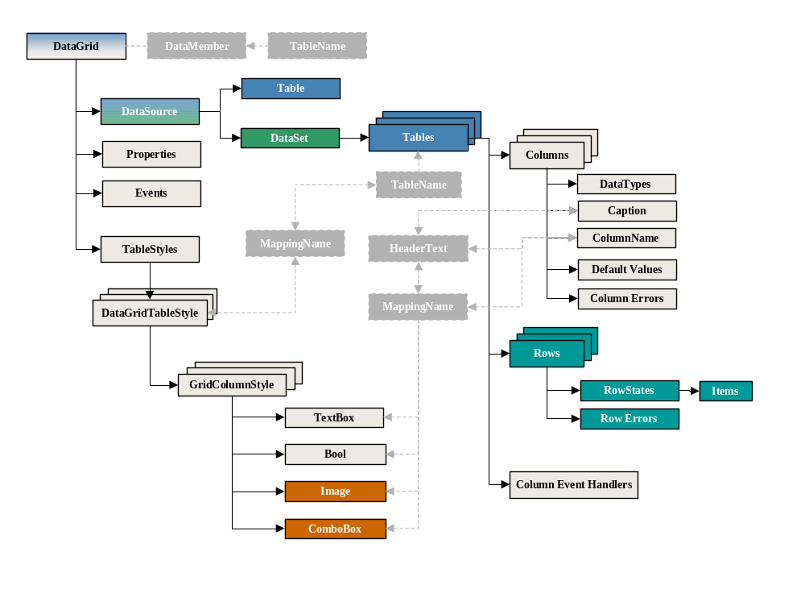

Figure 1 DataGrid, DataSet and DataTable relationship diagram

DataTables
The architecture and capability of DataTables should be understood since it carries over to understanding how a DataSet and DataGrid function. In the process of binding a DataGrid to a database the underlying code creates and associates collections of tables that are filled with data from the database. Also, a DataSet created from a database may contain tables with more information than needs to be displayed, columns may need to be added that are based upon complex formulas using information in other columns and data from multiple databases may need to be combined into a single tabular view. These operations are done by extracting information from these data sources and by filling a programmatically designed table that is unbound.
Fundamentally a table contains Columns and Rows collections, which means standard methods for accessing and manipulating collections can be used. The Columns collection contains, for each column, a name, a data type specification and maybe an assigned default value. Each table row in the Rows collection contains one cell for each column. The table class has an extensive set of methods for editing and managing versions of column and row data and for event notifications when changes occur. Figure 2 illustrates the overall architecture of a table.

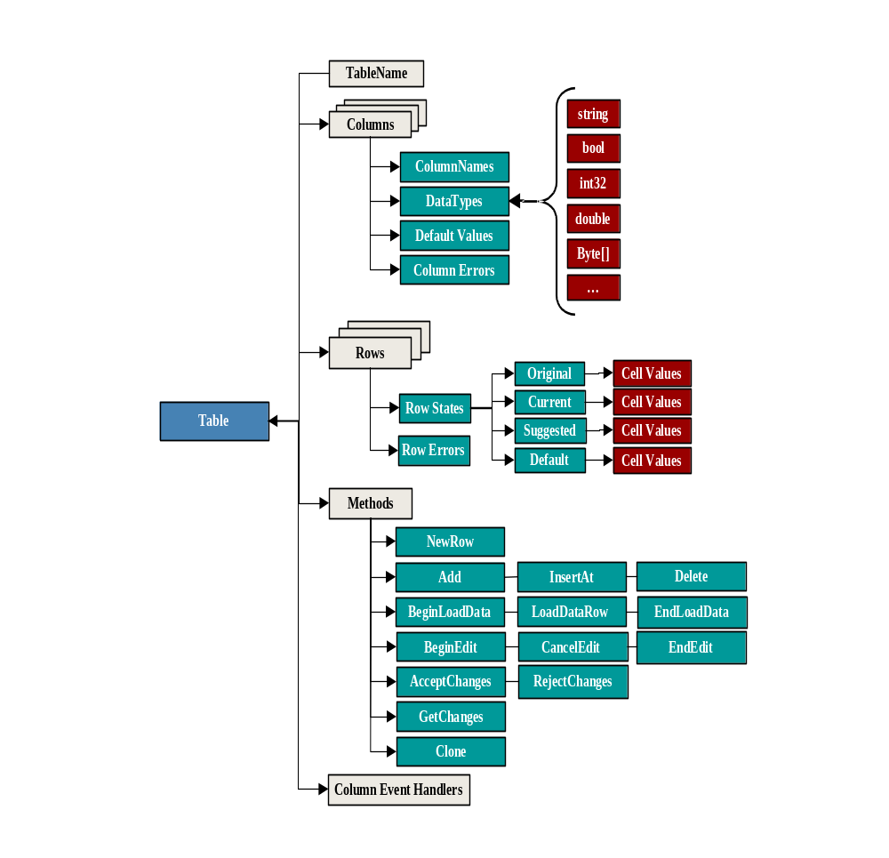
Figure 2 DataTable Decomposed

DataTable creation
A DataTable memory object that will be able to contain/manage columns, rows and events can be easily created from the DataTable class as follows:
// Create a table object by using the DataTable class:
DataTable dt = new DataTable();
// Name the table by assigning a data string containing the name to the table’s
// TableName property:
dt.TableName = “Elements”;
// or use the DataTable(string TableName) constructor
DataTable dt = new DataTable(“Elements”);

Columns – Creating and Adding to Tables
A table contains a collection of column definitions that will be used to define how each cell within a row can be referenced and the type of data content. The following scenario shows how to define a column and add it to a table’s column collection.

- Define a Table as described in the Tables section.
- Create a column object to be added to the table by using the column class:
DataColumn dc = new DataColumn();
// Set the properties for the column:
// string name for the column that is used as an index for columns collection
// and a cell within a row
dc.ColumnName = “AtomicNbr”;
// string name that is used for a column label or header for display purposes
// if not set, then the default value is dc.ColumnName
dc.Caption = “Atomic Number”;
// one of the standard system data types using the GetType() method.
dc.DataType = System.Type.GetType(“System.Int32);
// or one could use the typeof operator
dc.DataType = typeof(System.Int32);
// a default value that is assigned each time a new row is created
dc.DefaultValue = 0;
// or use one of the other constructor’s such as
// DataColumn(string ColumnName, System.Type DataType)
DataColumn dc = new DataColumn(“AtomicNbr”, System.Type.GetType(“System.Int32”));
- Add the new column to the table Columns collection. The order in which the columns are added determines their zero-based index.
dt.Columns.Add(dc);
- Repeat b and c for each column to be added to the table Columns collection.
dc = new DataColumn(“Element”, System.Type.GetType(“System.String”));
dc.DefaultValue = string.Empty;
dc.Caption = “Element”;
dt.Columns.Add(dc);
dc = new DataColumn(“Symbol”, System.Type.GetType(“System.String”) );
dc.DefaultValue = string.Empty;
dc.Caption = “Symbol”;
dt.Columns.Add(dc);
dc = new DataColumn(“AtomicMass”, System.Type.GetType(“System.Decimal”) );
dc.DefaultValue = 0.0;
dc.Caption = “Atomic Mass”;
dt.Columns.Add(dc);

Examples of data types supported in the .NET environment.
Data Type | .NET System Types
Boolean | System.Boolean
Byte | System.Byte
Byte[] (Array) | System.Byte[]
Char (Chararacter) | System.Char
DateTime | System.DateTime
Decimal | System.Decimal
Double | System.Double
Integer | System.Int16, System.Int32, System.Int64
Single | System.Single
String | System.String
Unsigned Integer | System.UInt16, System.UInt32, System.UInt64
TimeSpan | System.TimeSpan

At this point a table called “Elements” has been created with four columns “AtomicNbr”, “Element”, “Symbol” and “AtomicMass” with their respective data types and default values. The following three DisplayColumnInfo() method code examples show this by using different techniques for accessing members and displaying data from their collections. In the first example, a for-loop is used to illustrate accessing table column collections through an integer index while in the second example a foreach loop illustrates accessing the same collections using a column class type. The third example uses strings containing the column names as an index. These accessing data examples illustrate the natural syntax approaches for working with collections.
- for-loop
private void DisplayColumnInfo(DataTable dt)
{
StringBuilder ColInfo = new StringBuilder();
ColInfo.AppendFormat(“Column\tName\tDataType\n”);
// note that the total number of columns in the collection is contained in the ‘Count’ property
for(int j=0; j<dt.Columns.Count; j++)
{
ColInfo.AppendFormat(“ [{0}]\t{1}\t{2}\ t{3}\n”, j, dt.Columns[j].ColumnName,
dt.Columns[j].Caption, dt.Columns[j].DataType.ToString());
}
MessageBox.Show(ColInfo.ToString() , “Column Name”, MessageBoxButtons.OK,
MessageBoxIcon.Information);
}
- foreach loop
private void DisplayColumnInfo(DataTable dt)
{
StringBuilder ColInfo = new StringBuilder();
ColInfo.AppendFormat(“Column\tName\tDataType\n”);
int j = -1;
foreach (DataColumn dc in dt.Columns)
{
ColInfo.AppendFormat(“ [{0}]\t{1}\t{2}\t{3}\n”, ++j, dc.ColumnName,
dc.Caption, dc.DataType.ToString() );
}
MessageBox.Show(ColInfo.ToString(), “Column Name”, MessageBoxButtons.OK,
MessageBoxIcon.Information);
}

- Using known column names as indexes – not column captions!
private void DisplayColumnDataTypeInfo(DataTable dt)
{
StringBuilder ColInfo = new StringBuilder();
ColInfo.AppendFormat(“Column\tName\tDataType\n”);
ColInfo.AppendFormat(“ [{0}]\t{1}\t{2}\n”,1, “AtomicNbr”,
dt.Columns[“AtomicNbr”].DataType.ToString());
ColInfo.AppendFormat(“ [{0}]\t{1}\t{2}\n”,1, “Element”,
dt.Columns[“Element”].DataType.ToString());
ColInfo.AppendFormat(“ [{0}]\t{1}\t{2}\n”,1, “Symbol”,
dt.Columns[“Symbol”].DataType.ToString());
ColInfo.AppendFormat(“ [{0}]\t{1}\t{2}\n”,1, “AtomicMass”,
dt.Columns[“AtomicMass”].DataType.ToString());
MessageBox.Show(ColInfo.ToString() , “Column Name”, MessageBoxButtons.OK,
MessageBoxIcon.Information);
}

Deleting/Removing Columns
Once a table has been defined columns can be deleted or removed as follows:

// For example to delete a column “AtomicMass”
dt.Columns.Remove(“AtomicMass”);

// or using a zero-based index – “AtomicMass” is the 4th column with index 3
dt.Columns.RemoveAt(3);

// To make sure that a column can be removed, for example, first determine
// whether the column exists, belongs to the table, or is involved in a constraint
// or relation.
if (dt.Columns.Contains("AtomicMass"))
if (dt.Columns.CanRemove(dt.Columns["AtomicMass"])
{
dt.Columns.Remove(“AtomicMass”);
}

Modifying Column Properties
Modifying a column property is simply accessing the property and setting its new value. For example:

dt.Columns[“AtomicNbr”].ColumnName = “AtomicNumber”;
dt.Columns[“AtomicMass”].DataType = typeof(System.float);

Clearing Column Collection
The entire table column collection can be cleared by simply using the Clear() method.

dt.Columns.Clear();

Cloning a Table
Once a table has been defined it can be used to create an identical table with the same column collection or it can be used as a basis for a new table where columns will be deleted, added or modified. The original table’s Clone() method is used to create the new table with the same structure including schemas and constraints; however, it does not copy the content contained in the rows.

DataTable dt1 = dt.Clone();

Now dt1 can be changed, for example:

// delete a column
dt1.Columns.Remove(“AtomicMass”);

// add a new column to the table
dc = new DataColumn(“IsotopeNbr”, System.Type.GetType(“System.Int32”));
dc.DefaultValue = 0;
dt1.Columns.Add(dc);
// modify the name and caption of an existing column
dt1.Columns[“AtomicNbr”].ColumnName = “AtomicNumber”;

Note:
When the column name changes; the new column name must be used in any further references to the column.

dt1.Columns[“AtomicNumber”].Caption = “Atomic Number”;

Rows – creating and adding to a table.
This section will show how to add rows and assign values to rows in the table rows collection using four equivalent methods for accessing individual cells within a row. The choice of method really depends upon the type of task such as the source of the data being used to fill the rows or simply extracting data from the rows.
- Define a Table with Columns as described in the Tables and Columns section
- The following scenario is the fundamental procedure for creating a row, filling the cells in the row and then adding the row to the table. This section also illustrates equivalent ways to index a cell, which provides the developer with much flexibility.
// First create a DataRow variable
DataRow dr;
// Next create a new row and assign it to the DataRow object dr using DataTable’s
// NewRow() method.
dr = dt.NewRow();
// dr now contains a cell for each column defined in the Columns collection
Four equivalent methods used to assign values to individual cells within a row.
Method 1
// fill each cell using a zero-based cell integer column indexes
dr[0] = 1;
dr[1] = “Hydrogen”;
dr[2] = “H”;
dr[3] = 1.0078;
Method 2
// fill each cell using the column name as the string column index
dr[“AtomicNbr”] = 1;
dr[“Element”] = “Hydrogen”;
dr[“Symbol”] = “H”;
dr[“AtomicMass”] = 1.0078;
Method 3
// fill each cell using DataColumn dc -- this is more applicable
// when using a DataColumn foreach loop
// e.g. foreach (DataColumn dc in dt.Rows) …
DataColumn dc;
dc = dt.Columns[“AtomicNbr”];
dr[dc] = 1;
dc = dt.Columns[“Element”];
dr[dc] = “Hydrogen”;
dc = dt.Columns[“Symbol”];
dr[dc] = “H”;
dc = dt.Columns[“AtomicMass”];
dr[dc] = 1.0078;
Method 4
// fill each cell using DataColumn dc and its ColumnName property
// which is identical to Method 3 but is included here for completeness
// Again, more applicable when using a foreach loop
DataColumn dc;
dc = dt.Columns[“AtomicNbr”];
dr[dc.ColumnName] = 1;
dc = dt.Columns[“Element”];
dr[dc.ColumnName] = “Hydrogen”;
dc = dt.Columns[“Symbol”];
dr[dc.ColumnName] = “H”;
dc = dt.Columns[“AtomicMass”];
dr[dc.ColumnName] = 1.0078;
// add the row to the table’s row collection
dt.Rows.Add(dr);
- This scenario can be easily extended to a more general procedure to add n rows to the table. For example suppose a two dimensional object array ‘ElementData’ with n rows and dt.Columns.Count columns contains data to be added to the table. It could be loaded as follows:
DataRow dr;
int j;
for (int i=0; i < n; i++)
{
j = -1;
dr = dt.NewRow();
foreach (DataColumn dc in dt.Columns)
{
j++;
// fill each cell, using the column dc as the index, from the
// previously defined two dimensional object array → ElementData
if (dc.DataType == typeof(System.String))
dr[dc] = (System.String)ElementData[i][j];
else
if (dc.DataType == typeof(System.Int32))
dr[dc] = (System.Int32)ElementData[i][j];
else
if (dc.DataType == typeof(System.Decimal))
dr[dc] = (System.Decimal)ElementData[i][j];
}
dt.Rows.Add(dr);
}

Modifying data within an existing table row
There are a number of ways to modify data in a table with the following illustrating the basic mechanism. Other techniques will be presented in the following sections.

// First create a DataRow variable
DataRow dr;

// Next assign the row in the Rows collection to be modified to dr, for example select row with index = 0
dr = dt.Rows[0];

// Select the column within the row to be modified by specifying a column index and assign the new value
dr[“AtomicNbr”] = 1.00781;

Equivalent alternative coding methods are as follows:
dt.Rows[0][“AtomicNbr”] = 1.00781;

or

dt.Rows[0][0] = 1.00781;

Fill Table using LoadDataRow() method
The LoadElementDataRow()code example method in this section illustrates loading data into a table using the DataTable’s LoadDataRow method that takes an object containing data for each cell within a row. The LoadDataRow method is bracketed by BeginLoadData() and EndLoadData() methods that turn off and on event notifications and other properties related to linked tables. Using these methods can prevent unnecessary processing by event handlers that would otherwise be triggered that are discussed in the Event Handler section. Also, the LoadDataRow method will modify an existing row if primary keys match or add the row to the Rows collection. Refer to the section on Row Versions that discusses the different versions of rows managed by the table’s class for sample code illustrating the different behaviors of the LoadDataRow method when a table has a primary key and when it does not.

private DataRow LoadElementDataRow(DataTable dt, int AtomicNbr, string Element,
string Symbol, double AtomicMass)
{
// Turns off event notifications, index maintenance, and constraints while loading data
dt.BeginLoadData();

// Add the row values to the rows collection and return the DataRow. If the second
// argument is set to true, then dt.AcceptChanges() is called otherwise new rows are
// marked as additions and changes to existing rows are marked as modifications.
DataRow dr = dt.LoadDataRow(new object[] {AtomicNbr, Element, Symbol, AtomicMass}
, false);
// Turns on event notifications, index maintenance, and constraints that were turned off
// with the BeginLoadData() method
dt.EndLoadData();
return dr; // returns the DataRow filled with the new values
}

Retrieving Table Content
The GetTableData() example method retrieves the column labels and row data from an input table and formats them into a string that can be used for printing, copying to the clipboard and exporting to a tab delimited text file.
private string GetTableData(DataTable dt)
{
StringBuilder TableData = new StringBuilder();
// retrieve header row column labels
TableData.AppendFormat(“Row”);
foreach (DataColumn dc in dt.Columns)
TableData.AppendFormat(“\t{0}”, dc.ColumnName);
TableData.AppendFormat(“\n”);
// retrieve rows
int j = -1;
foreach (DataRow dr in dt.Rows)
{
TableData.AppendFormat(“[{0}]”,++j);
foreach (DataColumn dc in dt.Columns)
{
TableData.AppendFormat(“\t{0}”, dr[dc] );
}
TableData.AppendFormat(“\n”);
}
return TableData.ToString();
}
The output string for our element table with one row would look like the following when it is displayed in a grid format using an Excel spreadsheet or the DataGrid.
Row | AtomicNbr | Element | Symbol | AtomicMass
[0] | 1 | Hydrogen | H | 1.0078

Row Versions and Accepting/Rejecting Changes

Methods and Enumerations

This is an important section to understand because the Table class maintains different states and versions of rows that can be used to provide rollback, undo and transaction logging capability. That is, this state and version information provides very powerful programmatic control over table data and UI strategies.

Before discussing row states and versions there are Table and Row methods that need to be defined:
Table Method | Description
AcceptChanges() | Accepts all row changes to the table. Changes can be accepted to individual rows when the DataRow AcceptChanges() method is called.
RejectChanges() | Rejects all row changes to the table that have taken place since the last call to the Table or DataRow AcceptChanges().
GetChanges() | Returns a table containing all rows that have been modified. This is particular useful when building transaction logs to satisfy government and corporate regulations, such as CFR21-11.  Note: If the Table AcceptChanges is called prior to GetChanges then there will be no changes and the return value is null.

Rows Method | Description
Add() | Adds a row to the rows collection
InsertAt() | Inserts a row at a specific position in the rows collection
RemoveAt() | Removes a row at an index from the rows collection

AcceptChanges() | Accepts all changes to the row including changes to the individual cells including adding and deleting the row to and from the table respectively.
RejectChanges() | Rejects changes to the row restoring the original values
BeginEdit() | Begins a row editing session
CancelEdit() | Cancels a row editing session and restores all previous values
EndEdit() | Ends a row editing session

There are four different versions of Row Collections that are automatically maintained by the Table’s object that provides extensive programmatic control over edits, deletes and inserts.
DataRowVersion | Description
Current | This version contains the current set of all values contained in each table row. The current set and the default set are identical  - during modifying a row without calling BeginEdit()  - after AcceptChanges() is called.
Default | The Default rows collection contains all of the changes. Each time a new row is created the new row is initialized to the default column values. Each time a cell value within a row is modified, the modification will be reflected in this table.
Proposed | This version as its name implies contains only rows that have proposed changes where they are only present during a call to BeginEdit(). When EndEdit() is called the proposed changes are reflected in the Current DataRow, in the Original DataRow and proposed DataRow is deleted. When the CancelEdit is called, the proposed DataRow is deleted and the Default DataRow is changed back to the Current DataRow values.
Original | The Original Rows collection is updated each time AcceptChanges() is called. These values are used when RejectChanges() and CancelEdit() are called to return the values back to the state before any changes occurred since the last call to AcceptChanges().

RowState | Description
Added | The row is marked as Added when a row is added or inserted to the Rows Collection and before an AcceptChanges() method is called.
Deleted | After AcceptChanges() is called the row is marked as Deleted when any of the following is performed:  - dr.Delete()  - dt.Rows.RemoveAt(index)  - dt.Rows.Remove(dr)
Detached | Before AcceptChanges() is called the row is marked as Detached when any of the following is performed:  - dr.Delete()  - dt.Rows.RemoveAt(index)  - dt.Rows.Remove(dr)
Modified | After AcceptChanges() is called any row cell value that is changed causes the row to be marked as Modified.
Unchanged | After AcceptChanges() is called the row or all rows are marked as Unchanged depending upon whether it is a DataRow AcceptChanges() call or Table AcceptChanges() call.

DataTable dt = new DataTable("Elements");

DataColumn AtomicNbr = new DataColumn("AtomicNbr",System.Type.GetType("System.Int32"));
AtomicNbr.DefaultValue=0;
dt.Columns.Add(AtomicNbr);

DataColumn Element = new DataColumn("Element",System.Type.GetType("System.String"));
Element.DefaultValue= "Element";
dt.Columns.Add(Element);

DataRow dr;

Sample 1 – Row States
This section shows the different row states and the conditions for them.

dr = dt.NewRow();
dr[Element]="Hydrogen";
dr[AtomicNbr]= 1;
// NewRow Before Add: RowState=Detached

dt.Rows.Add(dr);
// NewRow After Add: RowState=Added

dt.Rows[0].AcceptChanges();
//NewRow After AcceptChanges: RowState=Unchanged

dt.Rows.RemoveAt(0);
// note that the row is marked as Detached when RemoveAt() or Remove() is used
//NewRow After RemoveAt: RowState=Detached

// Add the row back, accept the changes and then delete the row
// note that the row state is now marked as deleted when Delete()
// if Delete() is called prior to the row being added then the row is marked as Detached.
dt.Rows.Add(dr);
dt.AcceptChanges();

dr.Delete();
// NewRow After Delete: <RowState=Deleted>

The following code examples will illustrate the above method functionality. After each section of code will be four tables, one each for each type of DataRowVersion, that will show whether the version contains a row and if so their respective values.

NOTE
- Rows that do not exist (designated with a ‘No’ value under column ‘Has Versions’) for a particular RowState version are added or included for readability and clarity. That is, if all the rows in a version table were listed, these would not be in the Table Rows collection.

- The presentation schema is from code Sample 2 to Sample N where each successive code Sample uses the results from the previous Sample. All changes that occur to the version tables for Sample code section are designated in bold red.

Sample 2 – Initial Loading of Table

dr = dt.NewRow();
dr[Element]="Hydrogen";
dr[AtomicNbr]= 1;
dt.Rows.Add(dr);

dr = dt.NewRow();
dr[Element]="Helium";
dr[AtomicNbr]= 2;
dt.Rows.Add(dr);

dr = dt.NewRow();
dr[Element]="Lithium";
dr[AtomicNbr]= 3;
dt.Rows.Add(dr);

dr = dt.NewRow();
// this row contains default values
dt.Rows.Add(dr);

Row 0 has only an Original Version and it is marked as Deleted. The Current and Default versions are identical with the four new rows being marked as Added. The Proposed version table does not contain any values.

Current Version
Row | Has Versions | Row State | AtomicNbr | Element
[0] | No
[1] | Yes | Added | 1 | Hydrogen
[2] | Yes | Added | 2 | Helium
[3] | Yes | Added | 3 | Lithium
[4] | Yes | Added | 0 | Element

Default Version
Row | Has Versions | Row State | AtomicNbr | Element
[0] | No
[1] | Yes | Added | 1 | Hydrogen
[2] | Yes | Added | 2 | Helium
[3] | Yes | Added | 3 | Lithium
[4] | Yes | Added | 0 | Element

Original Version
Row | Has Versions | Row State | AtomicNbr | Element
[0] | Yes | Deleted | 0 | Element
[1] | No
[2] | No
[3] | No
[4] | No

Proposed Version
Row | Has Versions | Row State | AtomicNbr | Element
[0] | No
[1] | No
[2] | No
[3] | No
[4] | No

Sample 3 – DataRow AcceptChanges

dt.Rows[0].AcceptChanges();
dt.Rows[1].AcceptChanges();

After the Rows[0].AcceptChanges() was called, the row that was marked deleted, row 0 in the above version tables, has been deleted from all versions and all other rows have new indices. The next AcceptChanges() command references row 1 in the newly ordered Rows Collection. In this case, the Row State is marked as Unchanged in versions Current, Default and Original. In the Original version there is only one row and it corresponds to Row 1 that was accepted. The Proposed version table does not contain any values.

Current Version
Row | Has Versions | Row State | AtomicNbr | Element
[0] | Yes | Added | 1 | Hydrogen
[1] | Yes | Unchanged | 2 | Helium
[2] | Yes | Added | 3 | Lithium
[3] | Yes | Added | 0 | Element

Default Version
Row | Has Versions | Row State | AtomicNbr | Element
[0] | Yes | Added | 1 | Hydrogen
[1] | Yes | Unchanged | 2 | Helium
[2] | Yes | Added | 3 | Lithium
[3] | Yes | Added | 0 | Element

Original Version
Row | Has Versions | Row State | AtomicNbr | Element
[0] | No
[1] | Yes | Unchanged | 2 | Helium
[2] | No
[3] | No

Proposed Version
Row | Has Versions | Row State | AtomicNbr | Element
[0] | No
[1] | No
[2] | No
[3] | No

Sample 4 – Table AcceptChanges

dt.AcceptChanges();

After the Table.AcceptChanges() is called, all remaining rows are marked Unchanged in the Current, Default and Original Version tables and the Original version table is identical to the Current and Default version tables. The Proposed version table does not contain any rows.

Current Version
Row | Has Versions | Row State | AtomicNbr | Element
[0] | Yes | Unchanged | 1 | Hydrogen
[1] | Yes | Unchanged | 2 | Helium
[2] | Yes | Unchanged | 3 | Lithium
[3] | Yes | Unchanged | 0 | Element

Default Version
Row | Has Versions | Row State | AtomicNbr | Element
[0] | Yes | Unchanged | 1 | Hydrogen
[1] | Yes | Unchanged | 2 | Helium
[2] | Yes | Unchanged | 3 | Lithium
[3] | Yes | Unchanged | 0 | Element

Original Version
Row | Has Versions | Row State | AtomicNbr | Element
[0] | Yes | Unchanged | 1 | Hydrogen
[1] | Yes | Unchanged | 2 | Helium
[2] | Yes | Unchanged | 3 | Lithium
[3] | Yes | Unchanged | 0 | Element

Proposed Version
Row | Has Versions | Row State | AtomicNbr | Element
[0] | No
[1] | No
[2] | No
[3] | No

Sample 5 – DataRow BeginEdit

dt.Rows[1].BeginEdit();

dt.Rows[1]["Element"]= "Helium";
dt.Rows[1]["AtomicNbr"]= 222;

The above code begins an editing session on row 1 and the new values are reflected in the Default version table and values now appear in the Proposed version table. All other table version entries remain unchanged.

Current Version
Row | Has Versions | Row State | AtomicNbr | Element
[0] | Yes | Unchanged | 1 | Hydrogen
[1] | Yes | Unchanged | 2 | Helium
[2] | Yes | Unchanged | 3 | Lithium
[3] | Yes | Unchanged | 0 | Element

Default Version
Row | Has Versions | Row State | AtomicNbr | Element
[0] | Yes | Unchanged | 1 | Hydrogen
[1] | Yes | Unchanged | 222 | Helium
[2] | Yes | Unchanged | 3 | Lithium
[3] | Yes | Unchanged | 0 | Element

Original Version
Row | Has Versions | Row State | AtomicNbr | Element
[0] | Yes | Unchanged | 1 | Hydrogen
[1] | Yes | Unchanged | 2 | Helium
[2] | Yes | Unchanged | 3 | Lithium
[3] | Yes | Unchanged | 0 | Element

Proposed Version
Row | Has Versions | Row State | AtomicNbr | Element
[0] | No
[1] | Yes | Unchanged | 222 | Helium
[2] | No
[3] | No

Sample 6 – DataRow CancelEdit

dt.Rows[1].CancelEdit();

The CancelEdit() command returns the default values back to the Original state and clears out the Proposed values from row 1 in the Proposed version table.

Current Version
Row | Has Versions | Row State | AtomicNbr | Element
[0] | Yes | Unchanged | 1 | Hydrogen
[1] | Yes | Unchanged | 2 | Helium
[2] | Yes | Unchanged | 3 | Lithium
[3] | Yes | Unchanged | 0 | Element

Default Version
Row | Has Versions | Row State | AtomicNbr | Element
[0] | Yes | Unchanged | 1 | Hydrogen
[1] | Yes | Unchanged | 2 | Helium
[2] | Yes | Unchanged | 3 | Lithium
[3] | Yes | Unchanged | 0 | Element

Original Version
Row | Has Versions | Row State | AtomicNbr | Element
[0] | Yes | Unchanged | 1 | Hydrogen
[1] | Yes | Unchanged | 2 | Helium
[2] | Yes | Unchanged | 3 | Lithium
[3] | Yes | Unchanged | 0 | Element

Proposed Version
Row | Has Versions | Row State | AtomicNbr | Element
[0] | No
[1] | No
[2] | No
[3] | No

Sample 7 – DataRow BeginEdit – Example 2

dt.Rows[3].BeginEdit();

The BeginEdit() method initializes the Proposed row 3 with default values.

Current Version
Row | Has Versions | Row State | AtomicNbr | Element
[0] | Yes | Unchanged | 1 | Hydrogen
[1] | Yes | Unchanged | 2 | Helium
[2] | Yes | Unchanged | 3 | Lithium
[3] | Yes | Unchanged | 0 | Element

Default Version
Row | Has Versions | Row State | AtomicNbr | Element
[0] | Yes | Unchanged | 1 | Hydrogen
[1] | Yes | Unchanged | 2 | Helium
[2] | Yes | Unchanged | 3 | Lithium
[3] | Yes | Unchanged | 0 | Element

Original Version
Row | Has Versions | Row State | AtomicNbr | Element
[0] | Yes | Unchanged | 1 | Hydrogen
[1] | Yes | Unchanged | 2 | Helium
[2] | Yes | Unchanged | 3 | Lithium
[3] | Yes | Unchanged | 0 | Element

Proposed Version
Row | Has Versions | Row State | AtomicNbr | Element
[0] | No
[1] | No
[2] | No
[3] | Yes | Unchanged | 0 | Element

Sample 8 – DataRow Change values – Example 2

dt.Rows[3]["Element"]="Carbon";
dt.Rows[3]["AtomicNbr"]= 12;

The Default and Proposed row 3 values have been changed to reflect Carbon and 12. All other rows in all versions remain unchanged.

Current Version
Row | Has Versions | Row State | AtomicNbr | Element
[0] | Yes | Unchanged | 1 | Hydrogen
[1] | Yes | Unchanged | 2 | Helium
[2] | Yes | Unchanged | 3 | Lithium
[3] | Yes | Unchanged | 0 | Element

Default Version
Row | Has Versions | Row State | AtomicNbr | Element
[0] | Yes | Unchanged | 1 | Hydrogen
[1] | Yes | Unchanged | 2 | Helium
[2] | Yes | Unchanged | 3 | Lithium
[3] | Yes | Unchanged | 12 | Carbon

Original Version
Row | Has Versions | Row State | AtomicNbr | Element
[0] | Yes | Unchanged | 1 | Hydrogen
[1] | Yes | Unchanged | 2 | Helium
[2] | Yes | Unchanged | 3 | Lithium
[3] | Yes | Unchanged | 0 | Element

Proposed Version
Row | Has Versions | Row State | AtomicNbr | Element
[0] | No
[1] | No
[2] | No
[3] | Yes | Unchanged | 12 | Carbon

Sample 9 – DataRow EndEdit – Modified Rows

dt.Rows[3].EndEdit();

dt.Rows[0]["Element"] = "Oxygen";
dt.Rows[0]["AtomicNbr"] = 8;

// Add a new row.
dr = dt.NewRow();
dt.Rows.Add(dr);

After EndEdit() is called, the Current and Default versions for row 3 are updated and marked as Modified. The Original version for row 3 still retains the original values before the changes and is marked as Modified.

The next two lines assign “Oxygen” and its atomic number to row 0 and these values are reflected in the Current and Default versions, which are also marked as Modified. The Original version for row 0 remains unchanged.

The next two lines adds a new row to the Current and Default version tables initialized with default values and marked as Added. Note that the new row does not appear in the Original version table.

Current Version
Row | Has Versions | Row State | AtomicNbr | Element
[0] | Yes | Modified | 8 | Oxygen
[1] | Yes | Unchanged | 2 | Helium
[2] | Yes | Unchanged | 3 | Lithium
[3] | Yes | Modified | 12 | Carbon
[4] | Yes | Added | 0 | Element

Default Version
Row | Has Versions | Row State | AtomicNbr | Element
[0] | Yes | Modified | 8 | Oxygen
[1] | Yes | Unchanged | 2 | Helium
[2] | Yes | Unchanged | 3 | Lithium
[3] | Yes | Modified | 12 | Carbon
[4] | Yes | Added | 0 | Element

Original Version
Row | Has Versions | Row State | AtomicNbr | Element
[0] | Yes | Modified | 1 | Hydrogen
[1] | Yes | Unchanged | 2 | Helium
[2] | Yes | Unchanged | 3 | Lithium
[3] | Yes | Modified | 0 | Element
[4] | No

Proposed Version
Row | Has Versions | Row State | AtomicNbr | Element
[0] | No
[1] | No
[2] | No
[3] | No
[4] | No

Sample 10 – DataRow AcceptChanges of Modified Rows

dt.Rows[3].AcceptChanges();

The DataRow AcceptChanges() for row 3 causes the corresponding row in the Current and Default version tables to be marked as Unchanged and the Original version table now contains the same row values.

Current Version
Row | Has Versions | Row State | AtomicNbr | Element
[0] | Yes | Modified | 8 | Oxygen
[1] | Yes | Unchanged | 2 | Helium
[2] | Yes | Unchanged | 3 | Lithium
[3] | Yes | Unchanged | 12 | Carbon
[4] | Yes | Added | 0 | Element

Default Version
Row | Has Versions | Row State | AtomicNbr | Element
[0] | Yes | Modified | 8 | Oxygen
[1] | Yes | Unchanged | 2 | Helium
[2] | Yes | Unchanged | 3 | Lithium
[3] | Yes | Unchanged | 12 | Carbon
[4] | Yes | Added | 0 | Element

Original Version
Row | Has Versions | Row State | AtomicNbr | Element
[0] | Yes | Modified | 1 | Hydrogen
[1] | Yes | Unchanged | 2 | Helium
[2] | Yes | Unchanged | 3 | Lithium
[3] | Yes | Unchanged | 12 | Carbon
[4] | No

Proposed Version
Row | Has Versions | Row State | AtomicNbr | Element
[0] | No
[1] | No
[2] | No
[3] | No
[4] | No

Sample 11 – DataRow RejectChanges

dt.Rows[0].RejectChanges();

Calling the DataRow RejectChanges() method for row 0 causes the corresponding row values for the Current and Default tables to revert to the Original version values and three tables, Current, Default and Original, have the Row State for row 0 marked as unchanged.

Current Version
Row | Has Versions | Row State | AtomicNbr | Element
[0] | Yes | Unchanged | 1 | Hydrogen
[1] | Yes | Unchanged | 2 | Helium
[2] | Yes | Unchanged | 3 | Lithium
[3] | Yes | Unchanged | 12 | Carbon
[4] | Yes | Added | 0 | Element

Default Version
Row | Has Versions | Row State | AtomicNbr | Element
[0] | Yes | Unchanged | 1 | Hydrogen
[1] | Yes | Unchanged | 2 | Helium
[2] | Yes | Unchanged | 3 | Lithium
[3] | Yes | Unchanged | 12 | Carbon
[4] | Yes | Added | 0 | Element

Original Version
Row | Has Versions | Row State | AtomicNbr | Element
[0] | Yes | Unchanged | 1 | Hydrogen
[1] | Yes | Unchanged | 2 | Helium
[2] | Yes | Unchanged | 3 | Lithium
[3] | Yes | Unchanged | 12 | Carbon
[4] | No

Proposed Version
Row | Has Versions | Row State | AtomicNbr | Element
[0] | No
[1] | No
[2] | No
[3] | No
[4] | No

Sample 12 – LoadDataRow without table having primary key

dt.BeginLoadData();
dt.LoadDataRow(new object[]{1,"Deuterium"}, false);
dt.EndLoadData();

If a table does not have a primary key then the LoadDataRow method will create a new row and fill it with values in the object array. Looking at rows 0 and 5 in the Current and Default version tables, they both have the same atomic number, but different element names. Also, Row 5 is marked as being Added.

Current Version
Row | Has Versions | Row State | AtomicNbr | Element
[0] | Yes | Unchanged | 1 | Hydrogen
[1] | Yes | Unchanged | 2 | Helium
[2] | Yes | Unchanged | 3 | Lithium
[3] | Yes | Unchanged | 12 | Carbon
[4] | Yes | Added | 0 | Element
[5] | Yes | Added | 1 | Deuterium

Default Version
Row | Has Versions | Row State | AtomicNbr | Element
[0] | Yes | Unchanged | 1 | Hydrogen
[1] | Yes | Unchanged | 2 | Helium
[2] | Yes | Unchanged | 3 | Lithium
[3] | Yes | Unchanged | 12 | Carbon
[4] | Yes | Added | 0 | Element
[5] | Yes | Added | 1 | Deuterium

Original Version
Row | Has Versions | Row State | AtomicNbr | Element
[0] | Yes | Unchanged | 1 | Hydrogen
[1] | Yes | Unchanged | 2 | Helium
[2] | Yes | Unchanged | 3 | Lithium
[3] | Yes | Unchanged | 12 | Carbon
[4] | No
[5] | No

Proposed Version
Row | Has Versions | Row State | AtomicNbr | Element
[0] | No
[1] | No
[2] | No
[3] | No
[4] | No
[5] | No

Sample 13 – LoadDataRow with table having primary key

// must delete the row with a duplicate AtomicNbr in order to create
// a primary key.
dt.Rows.RemoveAt(5);
dt.AcceptChanges();

// Create a primary key and load the new object array data.
dt.PrimaryKey = new DataColumn[] {dt.Columns["AtomicNbr"]};
dt.BeginLoadData();
dt.LoadDataRow(new object[]{1,"Deuterium"}, false);
dt.EndLoadData();

If a table has a primary key then the LoadDataRow method will modify the data in the row if the primary keys match or else it will append the row to the table. Looking at row 0 in the Current and Default version tables, the element name has been changed from Hydrogen to Deuterium. In the three version tables Current, Default and Original row 0 is now marked as being Modified.

Current Version
Row | Has Versions | Row State | AtomicNbr | Element
[0] | Yes | Modified | 1 | Deuterium
[1] | Yes | Unchanged | 2 | Helium
[2] | Yes | Unchanged | 3 | Lithium
[3] | Yes | Unchanged | 12 | Carbon
[4] | Yes | Unchanged | 0 | Element

Default Version
Row | Has Versions | Row State | AtomicNbr | Element
[0] | Yes | Modified | 1 | Deuterium
[1] | Yes | Unchanged | 2 | Helium
[2] | Yes | Unchanged | 3 | Lithium
[3] | Yes | Unchanged | 12 | Carbon
[4] | Yes | Unchanged | 0 | Element

Original Version
Row | Has Versions | Row State | AtomicNbr | Element
[0] | Yes | Modified | 1 | Hydrogen
[1] | Yes | Unchanged | 2 | Helium
[2] | Yes | Unchanged | 3 | Lithium
[3] | Yes | Unchanged | 12 | Carbon
[4] | Yes | Unchanged | 0 | Element

Proposed Version
Row | Has Versions | Row State | AtomicNbr | Element
[0] | No
[1] | No
[2] | No
[3] | No
[4] | No

Sample Code for Obtaining Version and State Information

The above tables were generated using the following procedure.

static void PrintRowVersions(DataTable dt)
{

DataRowVersion[] rowVer = new DataRowVersion[4];
rowVer[0] = DataRowVersion.Current;
rowVer[1] = DataRowVersion.Default;
rowVer[2] = DataRowVersion.Original;
rowVer[3] = DataRowVersion.Proposed;
StringBuilder TableData = new StringBuilder();

for(int i=0; i<rowVer.Length; i++)
{
// Print the value of each column in each row.
TableData.AppendFormat("{0} Version\n", rowVer[i].ToString());
// retrieve header row column labels
TableData.AppendFormat("Row\tHas Versions\tRow State");
foreach (DataColumn dc in dt.Columns)
TableData.AppendFormat("\t{0}", dc.ColumnName);
TableData.AppendFormat("\n");

int n=-1;
foreach(DataRow row in dt.Rows )
{
n++;
if (row.HasVersion(rowVer[i]) )
{
// Print the specified version of the row's value.
TableData.AppendFormat("[{0}]\tYes\t{1}",
n.ToString(), row.RowState.ToString());

foreach (DataColumn dc in dt.Columns)
{
TableData.AppendFormat("\t{0}", row[dc,rowVer[i]]);
}
TableData.AppendFormat("\n");
}
else
{
TableData.AppendFormat("[{0}]\tNo\t", n.ToString());
for(int j=0; j<dt.Columns.Count; j++)
TableData.AppendFormat("\t ");
TableData.AppendFormat("\n");
}
}

TableData.AppendFormat("\n");

}
// output string data to a text file using a StreamWriter
// StreamWriter sw = new StreamWriter("c:\RowVersions.txt");
sw.Write(TableData.ToString());
// sw.Close();
}

Sorting DataTable Rows

A DataTable has a 'Select' Method that can be used to sort the rows within the table based upon a 'WHERE' clause (1st argument) and an 'ORDER BY' clause (2nd argument). The 'WHERE' clause contains an expression that is used to retrieve a subset of rows from the table. An expression is simply a set of conditions that column values must meet. The 'ORDER BY' clause contains an ordered set of sort keys (column names) and specifications on whether the column data is be sorted in Ascending (ASC) order or Descending (DESC) order. A 3rd argument in the method provides for specification of including rows in the sort that only belong to a particular DataViewRowState.

The original DataTable is not modified; instead, an array of DataRows is created forming a Result Set with each DataRow being associated with the original DataRow in the source DataTable. The returned rows cannot be inserted directly into a new table because an error will occur indicating that the row is already included in another table.

The enum values for DataViewRowState are:

Added, CurrentRows, Deleted, ModifiedCurrentState, ModifiedOriginal, None, OriginalRow, Unchanged.

Code example:

// select only rows where the Atomic Number of an element is greater than 5
// and less than 30
string strWhere = "AtomicNbr > 5 AND AtomicNbr < 30";

// Sort Descending by AtomicNbr
string strOrderBy = "AtomicNbr DESC";

// Use the Select method to find all rows matching the Where clause
// and the Order By clause. Consider all current Rows
DataRow[] returnedRows = ds.Tables["Elements"].Select(strWhere, strOrderBy, DataViewRowState.CurrentRows);

// The sorted rows are now accessible through the returnedRows array
// Accessing column data within the row is the same as for any DataRow
for (int j=0; j < returnedRows.Length; j++)
Console.WriteLine("AtomicNbr = " + returnedRows [j]["AtomicNbr"]
+ " Element = " + returnedRows [j]["Element"]);

Handling DataTable Errors
A DataTable can be checked to determine if it contains any rows with errors by examining the Table’s HasErrors property value. The following code illustrates how to isolate the rows and their columns with errors.

if (dt.HasErrors)
{ // Errors have occurred in rows in table dt

foreach (DataRow dr in dt.Rows)
{
if(dr.HasErrors)
{
// Row has errors
// GetColumnsInError() returns an array of DataColumns that contain errors
foreach(DataColumn dc in dr.GetColumnsInError())
{
// GetColumnError returns a description of the Column error
MessageBox.Show(dr.GetColumnError(dc.Ordinal));
}
}
}
}

DataTable Events
The following code provides an example of adding a DataTable column changed event handler and the code within the handler illustrates some techniques for processing the new column values.

dt.ColumnChanged += new DataColumnChangeEventHandler(this.SampleForm_ColumnChanged);

private void SampleForm_ColumnChanged(object sender, System.Data.DataColumnChangeEventArgs e)
{

if(e.Column.Ordinal <op> …)
{
// could perform validation checks such as range values
// or formatting or other types of processing on the changed column.
}

if(e.Row.HasErrors)
{
// clear the error
e.Row.SetColumnError(e.Column, string.Empty);
// check to see if row has any more errors
DataColumn [] dcErrors = e.Row.GetColumnsInError();
// if there are no more errors then clear the row error flag.
if(dcErrors.Length == 0)
e.Row.ClearErrors();
}
}

Data Sets

A DataSet is used to manage collections of table objects that are loaded from different data sources. DataSets can be loaded directly from bound databases and from programmatically creating tables and filling them with data for example: read in from text or binary files or through user inputs or through calculations. DataSets can also be loaded directly from XML files. Once loaded, the individual table objects can be accessed and manipulated by the methods and properties discussed in the Tables section.

DataSet Methods
DataSet Method | Description
AcceptChanges() | Accepts all changes to the DataSet
Clear() | Removes all rows from all tables in the DataSet – that is, removes all data.
Clone() | Creates a new DataSet with all tables having the same Table structure including any constraints and relationships. No Data is copied.
Copy() | Same as for the DataSet Clone() but it includes all Data.
GetChanges() | Creates a DataSet that contains all changes made to the dataset. If AcceptChanges was called then only changes made since the last call are returned.
HasChanges() | Returns true if any changes were made to the DataSet including adding tables and modifying rows.
WriteXml() | Outputs an XML file containing schema with all Tables, Data, Constraints and relationships.
ReadXml() | Inputs an XML file containing schema, Tables, Data, Constraints and relationships.

DataSet Properties
DataSet Property | Description
CaseSensitive | If set to true then string compares in DataSet tables are case sensitive otherwise they are not.
DataSetName | Name of the DataSet
HasErrors | Returns true if there are any errors within any tables in the DataSet
Relations | Collection of Relations
  Method/Property | Description
  Add() | Adds a new relation to the collection. That is,creates a user definable named relationship between two tables through a primary key – foreign key connection
  AddRange() | If two or more relations are to be added to the collection they can be added using this method. They are appended to the existing collection in the order specified in the range.
  CanRemove | Returns true if the relation can be removed from the collection
  Clear() | Removes all relations from the relations collection
  Contains() | Returns a true if the collection contains the named relation.
  Count | Returns the number of relations in the collection
  IndexOf() | Returns the index of a relation in the collection equal to name.
  Remove() | Removes a relation by Name from the collection
  RemoveAt() | Removes a relation by index from the collection.
Tables | Collection of Tables
  Method/Property | Description
  Add() | Adds a table to the collection
  AddRange() | If two or more tables are to be added to the collection they can be added using this method. They are appended to the existing collection in the order specified in the range.
  Clear() | Removes all tables from the collection
  Contains() | Returns a true if the collection contains a table with TableName equal to name.
  Count | Returns the number of tables in the collection
  IndexOf() | Returns the index of a table in the collection with a TableName equal to name.
  Remove() | Removes a table by TableName from the collection
  RemoveAt() | Removes a table by index from the collection.

Loading A DataSet

From a Table

Tables created and filled with data as discussed in the Tables section can be added to the Tables collection by using the Add() method or they can be added at once using the AddRange() method.

Example of Two equivalent methods used to add tables dtElements and dtIsotopes to the DataSet ElementDS using Add() and AddRange()
Method 1 – Tables.Add()
// Add the Elements table to the DataSet
elementDS.Tables.Add(dtElements);
// Add the Isotopes table to the DataSet
elementDS.Tables.Add(dtIsotopes);

Method 2 – Tables.AddRange()

ElementDS.Tables.AddRange(new DataTable(){dtElements, dtIsotopes});

From a Database

A DataSet tables collection can also be filled with linked tables containing data directly from a database recordset, which is considered bound data.

Method 1 – sqlDataAdapter
The following code illustrates how to directly load or bind a database recordset using the sqlDataAdapter’s Fill() method where the select query string was used to create the recordset. After the Fill() method is called, ds will contain a table in its collection with column headers that match the field names in the select query string and column datatypes will match those specified in the database table elements. Each row will contain data corresponding to each field.

System.Data.SqlClient.SqlConnection sqlConnection1;
System.Data.SqlClient.SqlDataAdapter sqlDataAdapter1;
System.Data.SqlClient.SqlCommand sqlSelectCommand1;

sqlConnection1 = new System.Data.SqlClient.SqlConnection();
sqlDataAdapter1 = new System.Data.SqlClient.SqlDataAdapter();
sqlSelectCommand1 = new System.Data.SqlClient.SqlCommand();

sqlSelectCommand1.CommandText = "SELECT ElementsID, AtomicNbr,”
+ “Symbol, AtomicMass, Element FROM [Elements]";

sqlDataAdapter1.SelectCommand = sqlSelectCommand1;
//
// sqlConnection1
// <replace xxxxx, nnnnn and dbName with appropriate values>
//
sqlConnection1.ConnectionString = “workstation id=xxxxx;packet “
+ “ size=4096;user id=nnnnn; pwd=yyyyy;data “
+ “ source=xxxxx; persist”
+ “ security info=False; initial catalog=dbName”;

sqlSelectCommand1.Connection = sqlConnection1;

DataSet ds = new DataSet();
sqlDataAdapter1.Fill(ds);

Method 2 – sqlDataReader

This method is more complex than using the sqlDataAdapter’s Fill() method, but it allows for preprocessing of data prior to populating table rows and the data is not bound directly to the database. In the example, instead of restricting the database record set to contain distinct Atomic Number rows through a SQL query, it is done programmatically for illustration purposes.

string SQL= "SELECT ElementsID, AtomicNbr, Symbol, AtomicMass, Element”
+ “ FROM [Elements] order by AtomicNbr ASC";
sqlConnection sqlConnection1=
new sqlConnection ("connection info to MSDE or SQL Server 2000+”;);
sqlCommand sqlCommand = new sqlCommand (SQL,sqlConnection1);
sqlConnection1.Open();
sqlDataReader elementReader = SqlCommand.ExecuteReader();

// Starting with the element table dt defined in the Tables section, an ElementID column
// is added that will be used as the primary key for the row.

DataColumn dc = new DataColumn(“ElementsID”, System.Type.GetType(“System.Guid”));
dt.Columns.Add(dc);

// Make ‘ElementsID’ a primary key:

dt.PrimaryKey = new DataColumn[]{dt.Columns["ElementsID"]};

// Fill table dt with data from the database table Elements:

Note: the sqlDataReader class has a method that can be used to determine whether a null or non-existent value was returned for a particular cell. For example:

If (!elementReader.IsDBNull(elementReader.GetOrdinal("AtomicNbr")))
{
// fill cell with value
}
else
{
// handle this condition
// for example fill cell with a default value
}
This check has been omitted in the following code for clarity, but it is a good practice to use it.

DataRow dr;
int PrevAtomicNbr = 0;
try
{

while(myReader.Read())
{
if (PrevAtomicNbr != elementReader.GetInt32(elementReader.GetOrdinal("AtomicNbr")))
{
PrevAtomicNbr = elementReader.GetInt32(elementReader.GetOrdinal("AtomicNbr"));
dr = dt.NewRow();

dr[“ElementsID”] =
elementReader.GetGuid(elementReader.GetOrdinal("ElementsID"));
dr[“AtomicNbr”] = elementReader.GetInt32(elementReader.GetOrdinal("AtomicNbr"));
dr[“Symbol”] = elementReader.GetString(elementReader.GetOrdinal("Symbol));
dr[“Element”] = elementReader.GetString(elementReader.GetOrdinal("Element"));
dr[“AtomicMass”] =
elementReader.GetDecimal(elementReader.GetOrdinal("AtomicMass"));

dt.Rows.Add(dr);
}
}

}
finally
{
elementReader.Close();
sqlConnection1.Close();
}

dt.AcceptChanges();

// Add table dt to a new dataset ds and its tables collection

DataSet ds = new DataSet();
ds.Tables.Add(dt);

Linked Tables

This example shows how to link two tables together through a primary key. In this example a Table with TableName of Elements is created with a Primary key of ‘Atomic Number’. The second Table with TableName of Isotopes is linked through a relationship coupling its Atomic Number column to Elements primary key.

// create a new DataSet named Periodic that will hold two linked tables with
// TableNames of Elements and Isotopes respectively.

DataSet elementDS = new DataSet("Periodic");

// Create Elements Table
DataTable dtElements = new DataTable("Elements");

dtElements.Columns.Add("Atomic Number", typeof(int));
dtElements.Columns.Add("Element", typeof(string));
dtElements.Columns.Add("Symbol", typeof(string));

// Make ‘Atomic Number’ a primary key in Elements table
dtElements.PrimaryKey = new DataColumn[]
{dtElements.Columns["Atomic Number"]};

// Create Isotopes Table
DataTable dtIsotopes = new DataTable("Isotopes");

dtIsotopes.Columns.Add("Symbol", typeof(string));
dtIsotopes.Columns.Add("Atomic Number", typeof(int));
dtIsotopes.Columns.Add("Isotope Number",typeof(int));
dtIsotopes.Columns.Add("Percent Abundance",
typeof(System.Decimal))
dtIsotopes.Columns.Add("Atomic Mass", typeof(System.Decimal));

// Add tables to the Dataset using the Tables AddRange method
elementDS.Tables.AddRange(new DataTable(){dtElements, dtIsotopes});

// or individually Add the tables using the Tables Add method
elementDS.Tables.Add(dtElements);
elementDS.Tables.Add(dtIsotopes);

Dataset . Relations.Add()

// Add a relationship for Tables Elements and Isotopes
// through the primary key ‘Atomic Number’ in DataSet
// Periodic and name the relationship ‘Isotopes’. This name is
// used in the DataGrid to select table rows, in table Isotopes,
// that contain isotope values for the selected element.
// Note: Parent table (Elements) is listed before the child (Isotopes) in the argument list.

elementDS.Relations.Add("Isotopes",
elementDS.Tables["Elements"].Columns["Atomic Number"],
elementDS.Tables["Isotopes"].Columns["Atomic Number"] );

Linked tables in a dataset

Filling
Assume that another DataSet ds exists that has a table with index 0 in its Tables collection that contains both Element and Isotope data that will be used to fill rows in the linked tables contained in the elementDS DataSet tables collection as defined in the previous section. Assume Table[0] in DataSet ds has the following columns:

AtomicNbr, Element, Symbol, IsotopeNbr, PctAbundance and AtomicMass

where rows are sorted by Atomic numbers ascending and then by IsotopeNbr numbers ascending.

// Assign the table containing both Elements and Isotopes to dt using index 0
DataTable dt = ds.Tables[0];

// Create two DataTable variables dtElements and dtIsotopes and
// assign tables contained in the DataSet elementDS Tables
// collection using TableNames as indexes.
DataTable dtElements = elementDS.Tables[“Elements”];
DataTable dtIsotopes = elementDS.Tables[“Isotopes”];

DataRow drElement;
DataRow drIsotope;

int prevAtomicNbr = 0;

foreach (DataRow dr in dt.Rows)
{
if(prevAtomicNbr != (int)dr["AtomicNbr"])
{ //need only one row per AtomicNbr in Table[“Elements”]

// Fill an element row with data from dt.
prevAtomicNbr = (int)dr["AtomicNbr"];
drElement = dtElements.NewRow();

drElement["Atomic Number"] = dr["AtomicNbr"];
drElement["Element"] = dr["Element"];
drElement["Symbol"] = dr["Symbol"];

dtElements.Rows.Add(drElement);
}

// Fill an isotope row with data from dt.
drIsotope = dtIsotopes.NewRow();

drIsotope["Isotope Number"] = dr["IsotopeNbr"];
drIsotope["Symbol"] = dr["Symbol"];
drIsotope["Atomic Number"] = dr["AtomicNbr"];
drIsotope["Percent Abundance"] = dr["PctAbundance"];
drIsotope["Atomic Mass"] = dr["AtomicMass"];

dtIsotopes.Rows.Add(drIsotope);

}

Removing
To remove all linked tables or a selected table that is linked from the DataSet, it is first necessary to remove all relations, then constraints and then the table otherwise relationship/constraint table errors are generated.

The following code example provides a generic routine for removing all linked tables in a dataset.

public void RemoveAllTables(DataSet ds)
{
// need to do it in reverse order due to constraints
ds.Relations.Clear();
for (int i=ds.Tables.Count -1; i >=0; i--)
{

ds.Tables[i].Constraints.Clear();
ds.Tables.RemoveAt(i);
}
}

XML Export and Import DataSet Data

WriteXml

All tables with their schemas, relationships, constraints and data contained in a DataSet can be exported in XML by specifying a DataSet property Namespace and using the WriteXml method.

For example:
ds.Namespace = "http://www.mydomain.com/xmlfiles”
ds.WriteXml(FileName, XmlWriteMode.WriteSchema);

ReadXml

All tables with their schemas, relationships, constraints and data contained in an XML file are imported into a DataSet by specifying a DataSet property Namespace and using the ReadXml method. Once in the DataSet it is just like any other dataset.

For example:
DataSet ds = new DataSet();
ds.Namespace = "http://www.mydomain.com/xmlfiles";
ds.ReadXml(FileName, XmlReadMode.ReadSchema);

Handling DataSet Errors
Similar to the DataTable HasErrors property the DataSet HasErrors property returns true if any errors occurred in any of the tables being managed by the DataSet.

if(ds.HasErrors)
{ // One or more of the tables in the DataSet has errors.

MessageBox.Show("DataSet has Errors");
// Insert code to resolve errors.
// Refer to ‘Handling DataTable Errors’ section for example of
// handling errors within tables.
}

Updating Database with DataSet/DataTable changes
The following code shows how to create a DataSet containing only the changes that have occurred to tables within a DataSet. The new DataSet can be used for updating the database. In this code example two event handlers are hooked to the SqlDataAdapter da which are called once for each row as it is being updated. The code for the OnRowUpdating method shows how to determine the transaction type of Updating being performed through the SqlRowUpdatingEventArgs argument, to retrieve the column data from the transaction row, to build a transaction data string and to output the string. Transaction types are listed in the following table.

Transaction Types | Description
Insert | Set when inserting a new record
Update | Set when updating an existing record
Delete | Set when deleting an existing record
Select | Set when selecting or retrieving a record.

The OnRowUpdated method shows how to handle the situation if an error occurs during the updating of a row in the database. The SqlRowUpdatedEventArgs provides the functionality to determine if any errors occurred, to link the error message directly to the row through the Row.RowError property and to control processing once an error has occurred.

UpdateStatus States | Description
Continue | Continue even though the error has occurred.
ErrorsOccurred | Flag indicating that an error has occurred.
SkipAllRemainingRows | Cease processing of all remaining rows.
SkipCurrentRow | Continue but skip the row with the error.

The code shows hooking and unhooking the event handlers before and after the Update is performed to illustrate the process. Since event handlers do not need to be hooked, it shows how to hook them only when they are needed. For example, requirements may indicate that a 'Select Transaction Type' need not be logged.

// Create temporary DataSet variable.
DataSet dsChanges;

// GetChanges for modified rows only.
dsChanges = ds.GetChanges(DataRowState.Modified);

// Check the DataSet for errors.
if(!dsChanges.HasErrors)
{
// No errors were found, update the DBMS with the previously
// declared SqlDataAdapter da that was used to load the DataSet ds
//

da.RowUpdating += new SqlRowUpdatingEventHandler(OnRowUpdating);
da.RowUpdated += new SqlRowUpdatedEventHandler(OnRowUpdated);

int res = da.Update(dsChanges); // returns the number of rows updated

da.RowUpdating -= new SqlRowUpdatingEventHandler(OnRowUpdating);
da.RowUpdated -= new SqlRowUpdatedEventHandler(OnRowUpdated);
}

public void OnRowUpdated(object sender, SqlRowUpdatedEventArgs args)
{
if (args.Status == UpdateStatus.ErrorsOccurred)
{
// do only if an error occurred during updating
// flag the row with the type of error
args.Row.RowError = args.Errors.Message;

MessageBox.Show("Table: " + args.TableMapping.ToString() +
" Row Updating Error: " + args.Errors.Message,
"Error", MessageBoxButtons.OK, MessageBoxIcon.Error);

// set the update status possible values are:
//
// Continue
// ErrorsOccurred
// SkipAllRemainingRows
// SkipCurrentRow

// skip only this row.
args.Status = UpdateStatus.SkipCurrentRow;
}
}

public void OnRowUpdating(object sender, SqlRowUpdatingEventArgs args)
{
if (args.StatementType == StatementType.Insert)
{
// add Insert a new row transaction code here.

StringBuilder Transactions = new StringBuilder();

Transactions.AppendFormat("{0}: Table [{1}] Begin Row Insertion.\r\n",
DateTime.Now, args.TableMapping );

// loop through each column getting the column values in the transaction row.
foreach (DataColumn dc in args.Row.Table.Columns)
Transactions.AppendFormat(" .[{0}] = {1} .\r\n",
dc.ColumnName, args.Row[dc.ColumnName]);

Transactions.AppendFormat("{0}: Table [{1}] End Row Insertion.\r\n",
DateTime.Now,args.TableMapping );

// output the Transaction to a database, to a file, to a printer or … by calling
// your output method passing it the Transaction string and the type of transaction.
//
// WriteToDbTransactionLog(Transactions.ToString(), args.StatementType);
}
else
if (args.StatementType == StatementType.Delete)
{
// add Delete a row transaction code here.
}
else
if (args.StatementType == StatementType.Update)
{
// add Update an existing row transaction code here.
}
else
if (args.StatementType == StatementType.Select)
{
// add Select a row transaction code here.
}

}

Data Grid

A DataGrid is used to display an independent Table or a collection of Tables contained in a DataSet. It also provides a UI for editing, deleting and inserting records along with a set of event notifications for programmatic response and for data change tracking. In addition it supports a collection of DataGrid Table Styles that provides custom presentation for each table in its DataSource. WebForms and WinForms can both display a DataGrid bound and unbound to a database; however, there are significant differences in usage.

This section will present how to work with a DataGrid and its many features and different use models.

Methods and Properties
Methods | Description
Collapse | Collapse a specified row or all rows.
Expand | Expand a specified row or all rows
IsExpanded | Returns true if a specified row is expanded otherwise false.
NavigateBack | Navigates back to the previously displayed table in the grid.
NavigateTo | Navigate to a table in the grid.
SetDataBinding | Binds a dataset to the DataSource and selects a table.
Select | This method selects row and highlights it. It is not necessarily the same as the current row.
UnSelect | This method unselects a row and turns of highlighting. It does not change the current row.

Properties | Description
AllowSorting | Set to True allows column sorting using the column headers.
AllowNavigation | Allows navigation within the data grid using for example the arrow or tab keys.
AlternatingBackColor | This sets a background color for alternating rows in the DataGrid making it easier to read across a row.
DataSource | This returns or sets the source of data for the DataGrid. It is either a DataSet or a DataTable.
DataMember | This sets the table to be displayed. When the DataSource is a DataSet the DataGrid display is in a hierarchical mode, setting this to one of the Tables in the DataSet automatically forces it to be displayed.
CurrentCell | Gets or Sets the currently active cell including the CurrentRowIndex
CurrentRowIndex | Gets or Sets the current row

Assigning Data Sources
The DataSource for a DataGrid is either a Table or a DataSet. For example, a previously created DataTable dt object is assigned to the DataGrid as using the DataGrid’s DataSource member follows:

dg.DataSource = dt; // DataSource contains only a DataTable object

A DataSet that contains multiple tables in its table’s collection can be assigned using the DataGrid’s DataSource member as follows::

DataSet ds = new DataSet();
ds.Tables.Add(dt1);
ds.Tables.Add(dt2);
…
ds.Tables.Add(dtn);
dg.DataSource = ds; // DataSource contains a DataSet object

By default the first table in the collection is displayed in the DataGrid, but a particular table can be selected using the DataGrid’s DataMember property as follows:

dg.DataMember = dt2.TableName;

or equivalently:

dg.DataMember = ds.Tables[1].TableName; // zero-based index

or a DataSet can be assigned and a Table selected at the same time using the SetDataBinding() method as follows:
dg.SetDataBinding(ds, dt2.TableName);

Note:
The only restriction for DataSets is that tables must have a primary key, if not then an error will occur at the time of assigning the DataSet to the DataSource.

Formatting

DataGridTableStyle - WinForms
A DataTable is used to hold a collection of Column definitions and a collection of rows containing data for each column. A DataSet contains a collection of Tables and a DataGrid provides the interactive UI for the presentation of a table from a DataTable or from one contained in a DataSet.

The rendering of each table being managed by the DataGrid is carried out through the collections of individual table styles (DataGridTableStyle) where each table style contains a collection of column styles. Refer to Figure 1 for a pictorial view of these relationships.

Microsoft’s .NET IDE provides DataGridTextBoxColumn or DataGridBoolColumn objects that are as there name implies a TextBox and Boolean or CheckBox column respectively. The TextBox column is the default column type used when declaring a DataGrid.

Unique rendering for each column is provided through the column style properties and methods. In addition it is possible to modify the .NET provided column styles or define new column styles such as ComboBoxes and ImageControls that are inherited from the base classes.

Note: DataGridTableStyle is not available for WebForms instead one must use itemstyles – see WebForm example.

In the following example assume the following:
- A DataTable dt is defined
- A DataSet ds is defined and contains dt at index equal 0 in its Tables collection
- A DataGrid dg is defined with DataSource containing ds

Initially the DataGrid dg does not have any TableStyles contained in the TableStyles collection, which can be seen through the Count property value:

dg.TableStyles.Count;

Also, the dg.Controls collection only contains Vertical and Horizontal Scrollbar controls.

// First, a DataGridTableStyle object is declared that will hold a collection of
// GridColumnStyles.

System.Windows.Forms.DataGridTableStyle DGStyle = new DataGridTableStyle();

// In this example the .NET DataGridTextBoxColumn class is used.

DataGridTextBoxColumn textColumn;

// Loop through each Column in table dt to get a DataColumn object that will be used
// to define properties for its TextBoxColumn style.
foreach (DataColumn dc in dt.Columns)
{
textColumn = new DataGridTextBoxColumn();

// the MappingName must correspond to the Table Column Name
// in order to establish the relationship between them

textColumn.MappingName = dc.ColumnName;

// the HeaderText value is displayed in Header for the column, here
// the Caption value is used.
textColumn.HeaderText = dc.Caption;

// specify some other property values
textColumn.Width = 200;
textColumn.Alignment = System.Windows.Forms.HorizontalAlignment.Left ;
textColumn.ReadOnly = true;

// Add this column object with its specifications to the GridColumnStyles collection
DGStyle.GridColumnStyles.Add(textColumn);
}

// The name of the DataGridTableStyle must match that of the table
// Since the DataGrid can contain multiple tables, similar the TableStyles collection
// can contain multiple DataGridTableStyles, one for each table.
DGStyle.MappingName = ds.Tables[0].TableName;

DGStyle.AlternatingBackColor = Color.Gainsboro;
DGStyle.AllowSorting = false;
DGStyle.ReadOnly = true;

// The Clear() method is called to ensure that the previous style is removed.
dg.TableStyles.Clear();

// Add the new DataGridTableStyle collection to the TableStyles collection
dg.TableStyles.Add(DGStyle);

Change only one table’s DataGridTableStyles

The following shows how to change only one Table’s DataGridTableStyles. Assume the table’s style is contained in the TableStyles collection at index equal 0

// Clear only a single table of its GridColumnStyles
dgConversionTable.TableStyles[0].GridColumnStyles.Clear();

DataGridTextBoxColumn textColumn;

// Loop through each Column in table dt to get a DataColumn object that will be used
// to define properties for its TextBoxColumn style.
foreach (DataColumn dc in dt.Columns)
{
textColumn = new DataGridTextBoxColumn();

// the MappingName must correspond to the Table Column Name
// in order to establish the relationship between them

textColumn.MappingName = dc.ColumnName;

// the HeaderText value is displayed in Header for the column, here
// the Caption value is used.
textColumn.HeaderText = dc.Caption;

// specify some other property values
textColumn.Width = 200;
textColumn.Alignment = System.Windows.Forms.HorizontalAlignment.Left ;
textColumn.ReadOnly = true;

// Add this column object with its specifications to the GridColumnStyles collection
// for TableStyles[0]
dgConversionTable.TableStyles[0].GridColumnStyles.Add(textColumn);
}

Change a single column in a Table’s DataGridTableStyle

One or more columns in an existing Table’s DataGridTableStyles collection can be changed using code to similar to the following. In this example, the first method uses the HeaderText to find the column that is to be changed in a table that is named “Demo”. Once the desired object is obtained, the current HeaderText value for the TextBoxColumn “old header text” is changed to “new header text”. Also, the Width of the column is changed to 150. In the second example the Column MappingName must be used instead of the HeaderText if they are different.

Method 1 – for-loop through collection
In this example
GridColumnStylesCollection gcsColl = dgConversionTable.TableStyles[“Demo”].GridColumnStyles;

for (int i=0; i< gcsColl.Count; i++)
{
if(gcsColl[i].GetType() == typeof(DataGridTextBoxColumn))
{
DataGridTextBoxColumn textColumn = (DataGridTextBoxColumn)gcsColl[i];
If (textColumn.HeaderText == “old header text”)
{
textColumn.Width = 150;
textColumn.HeaderText = “new header text”;
break;
}

}
}

Method 2 – Direct access using column string name

This method can be used if you only want to change a specific column. Be sure to use the column MappingName and not its Caption or HeaderText if they are different.

GridColumnStylesCollection gcsColl = dgConversionTable.TableStyles[“Demo”].GridColumnStyles;

if(gcsColl.Contains("mappingName"))
if(gcsColl["mappingName "].GetType() == typeof(DataGridTextBoxColumn))
{
DataGridTextBoxColumn textColumn =
(DataGridTextBoxColumn)gcsColl["mappingName"];
textColumn.Width = 150;
textColumn.HeaderText = “new header text”;

}

Create a DataGridTableStyle for Tables Based upon its Data
Each Table within a DataSet can have its own presentation and property style. The formatDG method below provides an example of how to programmatically define a style for each table based upon the data type for each column. It enforces these business rules:

- Width of a column is greater than whichever is larger - the width of the ColumnName text string or the maximum of the string length of the content of each cell in that column. The maximum width is set to the width of 100 characters. The letter ‘W’ is added to each string for padding since it is usually the widest character in the alphabet.
- Columns of DataType System.String or System.Guid have Column alignment = HorizontalAlignment.Left and Readonly= false
- Columns of DataType of System.DateTime or typeof(int) have Column Alignment = HorizontalAlignment.Center and Readonly= false
- Columns of DateType System.Double, System.Float or System.Decimal have Column Alignment = HorizontalAlignment.Rignt and Readonly= false and a format of “0.00”
- The NullText property is set to string.empty. That is whenever a field has a null value then no text is displayed. This is only true for text columns and not for Boolean columns.
- Style Column MappingName is the column’s ColumnName that matches the name of the field in the corresponding database table while its HeaderText is set to the more readable string contained in the column’s Caption property.
- The name of the DataGridTableStyle is the same name as for the table. That is, both the DataSet Table and DataGridTableStyle collections are in sync through the use of the table name, which means that when the DataGrid displays the Table it will use the corresponding TableStyle.

NOTE: A VB.Net version of formatDG() written by Greg Dunn can be found in the Appendix.

public void formatDG(DataGrid dg)
{
// Assume DataGrid DataSource is a DataSet that contains at least one table.
if (dg.DataSource.GetType() == typeof(DataSet))
{
DataSet ds = (DataSet)dg.DataSource;
if (ds != null)
{
if(dg.TableStyles.Count > 0)
dg.TableStyles.Clear();

float prevSumWidths = 0.0f;
int maxHeight = 0;
int calcH = 0;

foreach (DataTable dt in ds.Tables)
{
// DataTable dt = ds.Tables[tableName];

DataGridTableStyle DGStyle = new DataGridTableStyle();
DGStyle.MappingName = dt.TableName;
DGStyle.AllowSorting = false;
DGStyle.AlternatingBackColor = Color.Gainsboro;

DataGridTextBoxColumn textColumn;
int nbrColumns = dt.Columns.Count;
DataRow dr;

ArrayList cWidths = new ArrayList();
Graphics g = dg.CreateGraphics();
Font f = dg.Font;
SizeF sf;

// get widths for each column header
foreach (DataColumn c in dt.Columns)
{
// "W" is used as padding
sf = g.MeasureString("W" + c.Caption, f);
cWidths.Add(sf.Width);
}

// loop through each row comparing against initial column
// width and then against each new maximum width based upon
// data contained in each row for that column.
string strTemp;
for(int i=0; i < dt.Rows.Count; i++)
{
dr = dt.Rows[i];
for (int j=0; j < nbrColumns; j++)
{
if(!Convert.IsDBNull( dr[j]))
{
strTemp = dr[j].ToString();
// careful strings can get
// very long, limit it to 100 characters
if(dr[j].GetType() ==
typeof(System.String) && strTemp.Length > 100)
sf = g.MeasureString("W" +
strTemp.Substring(0,100), f);
else
sf = g.MeasureString("W" + strTemp, f);
if(sf.Width > (float)cWidths[j])
cWidths[j] = sf.Width;
}
}
}

// set each column with its determined width
// set alignment for each column
// set format for decimal numbers
float sumWidths = 0.0f;

foreach (DataColumn c in dt.Columns)
{

if(c.DataType == typeof(bool))
{

DataGridBoolColumn boolColumn =
new DataGridBoolColumn();
boolColumn.MappingName = c.ColumnName;
boolColumn.HeaderText = " " + c.Caption;
boolColumn.Width = 50;
boolColumn.ReadOnly = false;

boolColumn.Alignment = HorizontalAlignment.Center ;
DGStyle.GridColumnStyles.Add(boolColumn);
sumWidths += boolColumn.Width;
}

else
{

textColumn= new DataGridTextBoxColumn();
textColumn.MappingName = c.ColumnName;
textColumn.HeaderText = " " + c.Caption;
textColumn.ReadOnly = false;
textColumn.NullText = string.empty;

if(c.DataType == typeof(System.Guid) ||
c.DataType == typeof(System.String))
{

textColumn.Alignment = HorizontalAlignment.Left ;

}
else
if(c.DataType == typeof(System.DateTime))
textColumn.Alignment =HorizontalAlignment.Center ;
else
if(c.DataType == typeof(int))
{
textColumn.Alignment =HorizontalAlignment.Center ;
}

else
{
textColumn.Alignment = HorizontalAlignment.Right ;
if(c.DataType == typeof(System.Double)
|| c.DataType ==typeof(System.Decimal)
|| c.DataType == typeof(float))
textColumn.Format = "0.00";

}

textColumn.Width = (int)(float)cWidths[c.Ordinal];
DGStyle.GridColumnStyles.Add(textColumn);
sumWidths += textColumn.Width;
if (maxHeight < textColumn.TextBox.Height)
maxHeight = textColumn.TextBox.Height;

}
}

dg.TableStyles.Add(DGStyle);
// Adjust width of DataGrid to match calculated widths
// select maximum width of all tables in the dataset
// Adjust width to fit inside the parent container’s width

if (prevSumWidths < sumWidths)
{
prevSumWidths = sumWidths;
prevSumWidths += dg.RowHeaderWidth;

if (dg.VisibleRowCount < dt.Rows.Count)
prevSumWidths += 16; // add width of scrollbar
// check to see if it is greater than the width of its parent
// e.g. a panel or tabpage control.
if (prevSumWidths > (float)dg.Parent.Width)
// allow room for the scroll bar and provide a little padding.
prevSumWidths = (float)dg.Parent.Width - 16 - 5;

}
// Adjust height of DataGrid based upon row visiblity
if (dg.VisibleRowCount >= dt.Rows.Count)
{
calcH = (dg.VisibleRowCount)*maxHeight+2*dg.PreferredRowHeight+16;
}
else
{
calcH = (dt.Rows.Count)*maxHeight+2*dg.PreferredRowHeight+16;
// make a correction since all rows will now be visible
if (calcH < dg.Parent.Height)
prevSumWidths -= 16;

}
if (calcH >=dg.Parent.Height)
{
calcH = dg.Parent.Height – dg.Top - 25; // some arbitrary value

}

}
dg.Size = new Size((int)prevSumWidths,calcH);
}
}

Defining DataGridTableStyles through Visual Studio .NET IDE

In the WinForm UI editor where a DataGrid control is placed onto the Form, the DataGridTableStyle’s collection property can be selected that will bring up the DataGridTableStyle Collection Editor dialog box shown in Figure 3. Clicking on the Add button will create a new DataGridStyle that can be named. Shown in member’s section of the dialog box are two styles names DGStyleElements and DGStyleIsotopes where the property values for the former are shown. Note that DGStyleElements has a MappingName of Elements and whenever the DataGrid MappingName is also Elements then this style will be used to render the DataTable with the same name.

Clicking on the GridColumnStyles collection property (indicated by Red Arrow) launches the DataGridColumnStyle Collection Editor dialog shown in Figure 4. In the member’s section is a list of column styles, one for each column that is in the Elements Table. Shown in the dialog are the property values for the TextBoxColumn style that is linked to the Atomic Number column in the Elements Table through the MappingName property.

The two dialog boxes in Figures 3 and 4 clearly show the DataGrid style collections of collections model that the DataGrid uses when rendering tables.

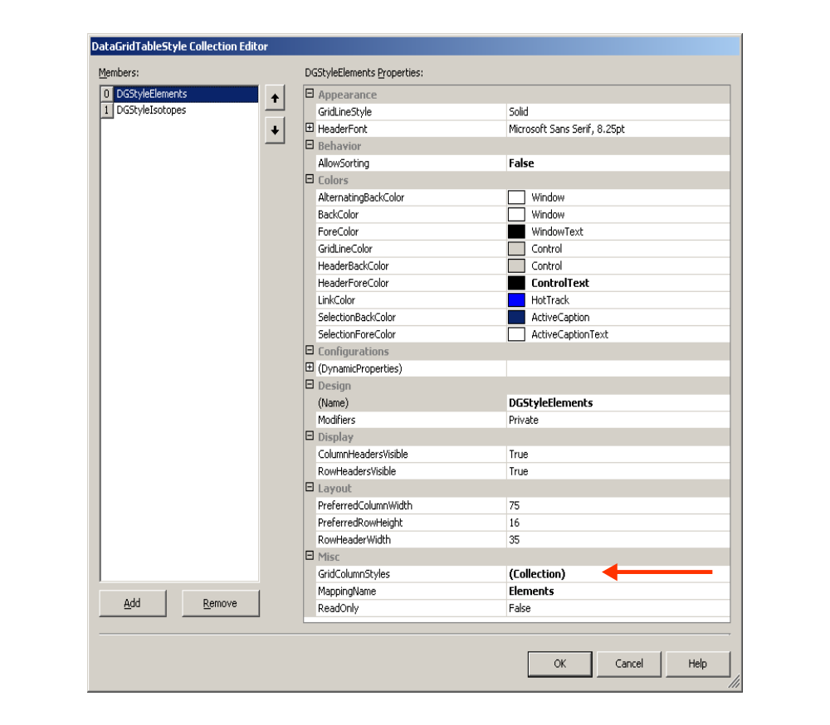

Figure 3 DataGridTableStyle Collection Editor Dialog Box

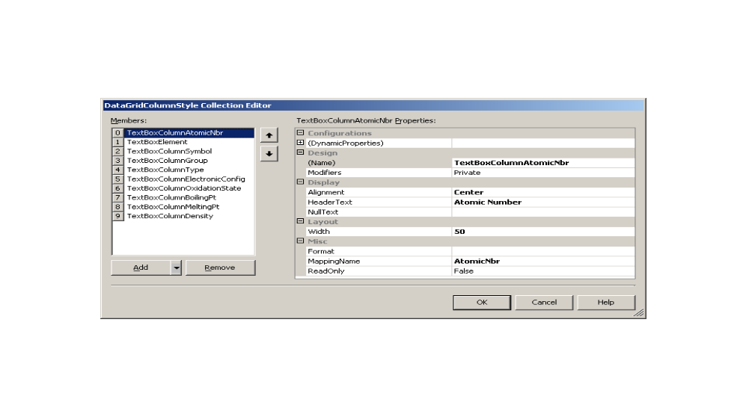

Figure 4 DataGridColumnStyle Collection Editor Dialog Box

Navigation

CurrencyManager

The CurrencyManager is especially useful when the DataSet contains linked tables and there is a need to make sure records are being added correctly or in navigating between them. The CurrencyManager’s Position property contains the zero-based index row number of the currently selected row of the table that it is bound to.

In a linked system such as the Element -> Isotope table relationship and the DataGrid DataMember property is set to the Isotope table, then the DataGrid CurrentRowIndex reflects the currently selected row in the Isotope table and the only way to know the row index in the Element table to which it is linked can only be determined by using the CurrencyManger for the Elements table.

The CurrencyManager can also be used to move to different rows in its bound table by using the Count property in conjunction with changing the value of the Position property; thus MoveNext, MovePrev, MoveFirst and MoveLast navigation methods can be created. Also when the position is changed the CurrencyManager’s CurrentChanged and PositionChanged events can be monitored.

For example a CurrencyManger object with event handling can be declared as follows:

private CurrencyManger cmElements;

cmElements = (CurrencyManager)this.BindingContext[dg.DataSource, "Elements"];

cmElements.CurrentChanged += new System.EventHandler(this.cmElements_CurrentChanged);

cmElements.PositionChanged += new System.EventHandler(this.cmElements_PositionChanged);

CurrentCell
The DataGridCell class constructor can be used to change the currently selected cell and row in the table currently active as specified by dg.DataMember. It also has two members that can be used to independently get or set the current table column and row numbers. For example:

dg.CurrentCell = new DataGridCell(row, column);
row = dg.CurrentCell.RowNumber;
column = dg.CurrentCell.ColumnNumber;

Selecting Rows

When coordinating a DataGrid with other types of UI components the CurrentRowIndex, Select and UnSelect methods need to be called.

Method | Action
dg.CurrentRowIndex=newRow; | Sets or Gets the new current row and moves the cursor indicator to that row. Refer to figure 3.
dg.Select(newRow); | Select() highlights the NewRow. Refer to figure 3.
dg.UnSelect(previousRow); | UnSelect() un-highlights the previousRow

Expand and Collapse linked tables

Figures 5 to 7 show tables in different states after calling the Collapse and Expand methods.

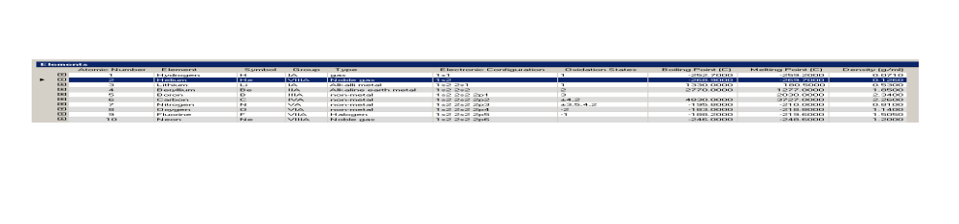
Figure 5 dg.Collapse(-1); // Collapses all rows

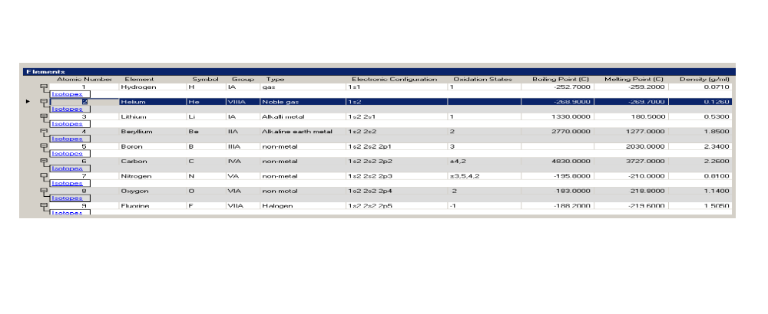
Figure 6 dg.Expand(-1); // Expands all rows

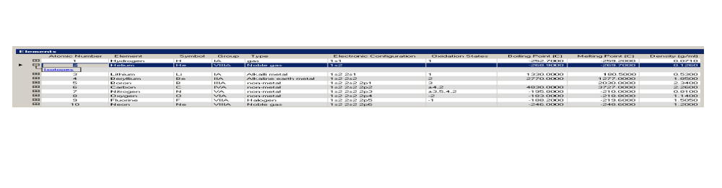
Figure 7 dg.Expand(1); // Expands only row 2 (zero based index)

Figure 8 illustrates the result of using the DataGrid NavigateTo(arg1, arg1) method where arg1 is an integer row index in the primary table and arg2 is a string specifying the name of the table to Navigate to. In this example, Mercury is at row index = 79 in the Elements table and isotopes are contained in the link table “Isotopes” through the Atomic Number primary key-foreign key relationship.

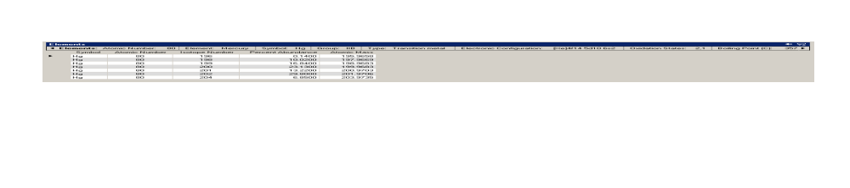

Figure 8 dg.NavigateTo(79, “Isotopes”);

Copy DataGrid to the Clipboard

The following sections contain Copy to Clipboard routines that access all tables or a specified table from a DataGrid and then they call a routine (TableToString) that formats table data into a string, which is copied to the Clipboard. Once the clipboard contains this string it can be pasted into Excel or into any other application that accepts text data. For example, in Excel or Winword the string data will be parsed back into tables.

Each of the methods checks the DataGrid data source member to determine whether it is a DataSet containing a collection of Tables or whether it is simply a Table Object.

Copy selected table in DataGrid to clipboard

public void CopyDGtoClipboard(DataGrid dg, string tableName)
{
if (dg.DataSource != null)
{

DataTable dt = null;
if (dg.DataSource.GetType() == typeof(DataSet))
{
DataSet ds = (DataSet)dg.DataSource;
// need to use tableName when DataSet contains more than
// one table
if (ds.Tables.Contains(tableName))
dt = ds.Tables[tableName];
}
else
if (dg.DataSource.GetType() == typeof(DataTable))
{
dt = (DataTable)dg.DataSource;
if (dt.TableName != tableName)
{
dt.Clear();
dt = null;
}
}

if (dt != null)
Clipboard.SetDataObject(TableToString (dt), true );

}
}

Copy all tables in DataGrid to clipboard

public void CopyDGtoClipboard(DataGrid dg)
{
if (dg.DataSource != null)
{

if (dg.DataSource.GetType() == typeof(DataSet))
{
DataSet ds = (DataSet)dg.DataSource;
if (ds.Tables.Count > 0)
{
string strTables = string.Empty;
foreach (DataTable dt in ds.Tables)
{
strTables += TableToString (dt);
strTables += "\r\n\r\n";
}
if (strTables != string.Empty)
Clipboard.SetDataObject(strTables, true );
}
}
else
if (dg.DataSource.GetType() == typeof(DataTable))
{
DataTable dt = (DataTable)dg.DataSource;
if (dt != null )
Clipboard.SetDataObject(TableToString(dt),
true );
}
}

}

Format table data into a string

This method returns a string containing the data in a DataTable object. The first line contains the name of the table, the second line contains the name of each column separated by a tab character and the remaining lines, one for each row in the table, contains the corresponding column data separated by a tab character.

private string TableToString(DataTable dt)
{
string strData = dt.TableName + "\r\n";
string sep = string.Empty;
if (dt.Rows.Count > 0)
{
foreach (DataColumn c in dt.Columns)
{
if(c.DataType != typeof(System.Guid) &&
c.DataType != typeof(System.Byte[]))
{
strData += sep + c.ColumnName;
sep = "\t";
}
}
strData += "\r\n";

foreach(DataRow r in dt.Rows)
{
sep = string.Empty;
foreach(DataColumn c in dt.Columns)
{
if(c.DataType != typeof(System.Guid) &&
c.DataType != typeof(System.Byte[]))
{
if(!Convert.IsDBNull(r[c.ColumnName]))
strData += sep +
r[c.ColumnName].ToString();
else
strData += sep + " ";
sep = "\t";
}
}
strData += "\r\n";
}
}
else
strData += "\r\n---> Table was empty!";

return strData;
}

Exporting to a Tabbed delimited Text File
The following two methods tabTextFile and SaveDataGridData along with the TableToString method defined in an another section can be used to save all data contained in the DataGrid to a tab delimited text file specified through a SaveAs Dialog box.

public void tabTextFile(DataGrid dg)
{
OpenFileDialog openFileDialog1 = new OpenFileDialog();

openFileDialog1.InitialDirectory = "c:\\" ;

openFileDialog1.Filter = "Text Files (*.txt)|*.txt| All files (*.*)|*.*" ;
openFileDialog1.RestoreDirectory = true ;
openFileDialog1.Title="Export DataGrid to Text File";
System.Windows.Forms.DialogResult res = openFileDialog1.ShowDialog();
if(res == DialogResult.OK)
{

DataSet ds = new DataSet();
DataTable dtSource = null;
DataTable dt = new DataTable();
DataRow dr;
if(dg.DataSource != null)
{
if (dg.DataSource.GetType() == typeof(DataSet))
{
DataSet dsSource = (DataSet)dg.DataSource;
// assume DataSet contains desired table at index 0
if (dsSource.Tables.Count > 0)
{
string strTables = string.Empty;
foreach (DataTable dt in dsSource.Tables)
{
strTables += TableToString (dt);
strTables += "\r\n\r\n";
}
if (strTables != string.Empty)
SaveDataGridData (strTables,openFileDialog1.FileName);
}

}
else
{
if (dg.DataSource.GetType() == typeof(DataTable))
dtSource = (DataTable)dg.DataSource;

if (dtSource != null )
SaveDataGridData (TableToString(dtSource),
openFileDialog1.FileName);
}

}
}
}

private void SaveDataGridData(string strData, string strFileName)
{
FileStream fs;
TextWriter tw = null;
try
{
if (File.Exists(strFileName))
{
fs = new FileStream(strFileName, FileMode.Open);
}
else
{
fs= new FileStream(strFileName, FileMode.Create);
}

tw = new StreamWriter(fs);
tw.Write(strData);

}
finally
{
if (tw != null)
{
tw.Flush();
tw.Close();

MessageBox.Show("DataGrid Data has been saved to: " + strFileName
,"Save DataGrid Data As"
, System.Windows.Forms.MessageBoxButtons.OK
, System.Windows.Forms.MessageBoxIcon.Information);

}
}
}

Cloning Table contained in a DataGrid
This example shows how to clone a table in a DataGrid and then fill the cloned table with the content from the original table and return it in a new DataSet. Note that it checks to determine whether the DataSource is a DataSet or a Table.

private DataSet CloneDataTable(DataGrid dgTable)
{
DataSet ds = new DataSet();
DataTable dtSource = null;
DataTable dt = new DataTable();
DataRow dr;
if(dgTable.DataSource != null)
{
if (dgTable.DataSource.GetType() == typeof(DataSet))
{
DataSet dsSource = (DataSet)dgTable.DataSource;
// assume DataSet contains desired table at index 0
dtSource = dsSource.Tables[0];

}
else
if (dgTable.DataSource.GetType() == typeof(DataTable))
dtSource = (DataTable)dgTable.DataSource;
if (dtSource != null)
{
dt = dtSource.Clone();
// dgConversionTable.CaptionText;
dt.TableName = dtSource.TableName;
dt.BeginLoadData();
foreach (DataRow drSource in dtSource.Rows)
{
dr = dt.NewRow();
foreach (DataColumn dc in dtSource.Columns)
{
dr[dc.ColumnName] = drSource[dc.ColumnName];
}
dt.Rows.Add(dr);
}
dt.AcceptChanges();
dt.EndLoadData();
ds.Tables.Add(dt);
}
}
return ds;
}

Comparison of WinForms & WebForms
This section will show differences between using a DataGrid in WinForms and WebForms. A table with a DataGrid caption of C-Terminal Groups will be used in the comparisons.

WinForms

In Figures 9 and 10, it can be seen that the C-Terminal table contains text, decimal numbers and integers that have been formatted using a procedure similar to formatDG(DataGrid dg) that us DataGridTableStyles. This DataGrid was formatted as follows:
- Integers are centered within the column
- Text strings are left justified. In the Formula column, which is generated from the values in the element decomposition columns, the electronic formula string has a space between each element instead of using numeric subscripts
- Decimal numbers have 4 decimal places and are right justified.
- The ID column is the primary key for the table.
- NOTE: dc.Caption is used as column headers in the DataGrid, in this case dc.Caption is equal to dc.ColumnName

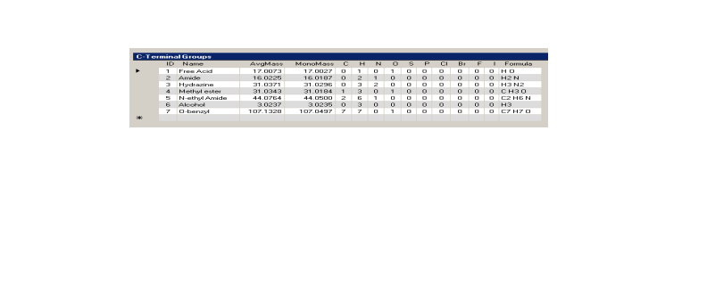
Figure 9 WinForm DataGrid displaying C-Terminal Groups

In Figure 10, row 3, Hydrazine in the Name column is being edited. That is, editing is performed directly within each cell by simply moving the cursor to the cell and clicking on the left mouse button to set the focus. The dark blue arrow on the left margin of the table moves to the row being edited. If there are more rows than can be displayed in the DataGrid view then a scroll bar is used to bring other rows into view.

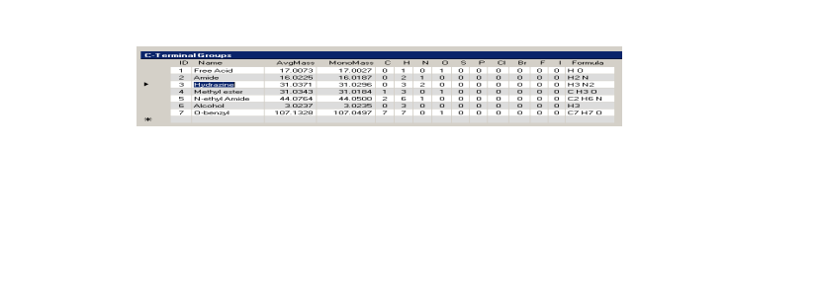
Figure 10 WinForm DataGrid editing directly in a cell

To add more rows, the procedure is to enter new values into each cell in the row marked with an asterisk. The table class manages all new cell and row entries. One of the available methods will return a value indicating that changes to the table has occurred and then other methods can be used to determine the types of changes and to create a table containing only the changes. Events handlers can also be implemented to respond as changes are being made.

WebForms

Figures 11 – 13 illustrate the same table as in the Web Form, but there are differences. First and foremost is that the DataGrid is really an HTML Table. This can be readily seen by looking at the Formula column in Figures 11 and 12. The numeric subscript values are formatted using the HTML <sub>…</sub> tags with numbers being obtained from the element decompositions columns {C, H, N, O, S, P, Cl, Br, F, I}. That is, all cell entries can modified using all style elements available in HTML. Below Figure 11 is listed the HTML code generated by Microsoft’s Visual Studio .NET IDE for the DataGrid. It contains user defined and default property values. Notice in the HTML code that the blue background with white letters is defined for the header as well as the additional Edit and Delete columns that are used when modifying row values. Also, since an HTML table does not have scroll bars, a paging mechanism (Prev, Next) can be used with the number of lines per page defined with the PageSize attribute.

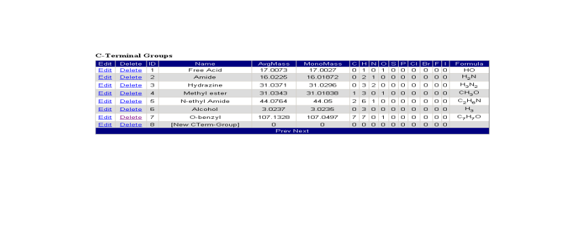
Figure 11 WebForm DataGrid being displayed as an HTML Table

HTML code that was generated for the DataGrid by Visual Studio .Net

<asp:datagrid id="dgCTerminalGroups" style="Z-INDEX: 103; LEFT: 72px;
POSITION: absolute; TOP: 464px"
runat="server" Font-Size="Small" Font-Names="Arial"
HorizontalAlign="Left" Width="656px" AllowPaging="True"
PageSize="10" CellPadding="3">

<AlternatingItemStyle BackColor="Gainsboro"></AlternatingItemStyle>

<ItemStyle Font-Size="Smaller" Font-Names="Arial"
HorizontalAlign="Center">
</ItemStyle>

<HeaderStyle Font-Size="Smaller" HorizontalAlign="Center" ForeColor="White"
BackColor="Navy">
</HeaderStyle>

<Columns>
<asp:EditCommandColumn ButtonType="LinkButton" UpdateText="Update"
HeaderText="Edit" CancelText="Cancel"
EditText="Edit"></asp:EditCommandColumn>

<asp:ButtonColumn Text="Delete" HeaderText="Delete"
CommandName="Delete"></asp:ButtonColumn>
</Columns>

<PagerStyle NextPageText="Next" Font-Size="Smaller" PrevPageText="Prev"
HorizontalAlign="Center"
ForeColor="White" BackColor="Navy"></PagerStyle>
</asp:datagrid>

Edit a row

When a rows Edit linkbutton is clicked each cell in the row is converted to a TextBox control with its TextBox.text property initialized to the value obtained in the table cell. This is illustrated in row 3 of Figure 12 where each TextBox Control has been formatted as presented in the section of the dg_PreRender(object sender, System.EventArgs e, string strTableName) procedure code that follows Figure 13 where the EditItemIndex member is greater than –1. Note that the ID and Formula columns TextBox control is readonly, DarkGray colored text and the Border Width is zero.

Also when a rows Edit linkbutton is clicked the EditCommand handler is called. All that this handler does is set the EditItemIndex member and then calls the DataBind() method.

private void dgCTerminalGroups_EditCommand(object source,
System.Web.UI.WebControls.DataGridCommandEventArgs e)
{
dgNTerminalGroups.EditItemIndex = e.Item.ItemIndex;
dgNTerminalGroups.DataBind();
}

Cancel editing a row

The edit operation can be canceled by clicking on the Cancel linkbutton where its CancelCommand event handler sets the EditItemIndex to –1 and then calls the DataBind() method.

private void dgNTerminalGroups_CancelCommand(object source,
System.Web.UI.WebControls.DataGridCommandEventArgs e)
{
dgNTerminalGroups.EditItemIndex = -1;
dgNTerminalGroups.DataBind();
}

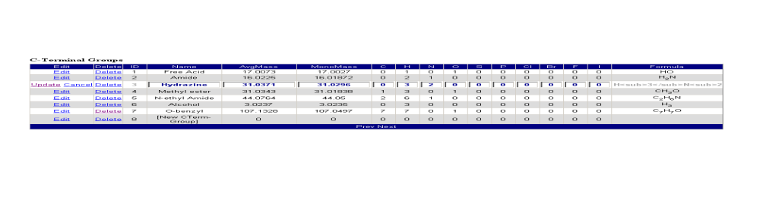

Figure 12 Editing C-Terminal Group row ID equal 3

Entering a new row

In the WinForm DataGrid a new row can be entered in the line designated with an asterisk, but this mechanism does not exist in WinForms. This implementation has created a special last row with a Key Phrase “[New CTerm-Group]” that lets the user know that this line is similar to the WinForm line with an asterisk and Edit will have the same behavior as the other lines. This line empty line was added to the DataTable after the object was filled from the database query and the update handler will remove this line prior to updating the database if no changes were made to the line other wise it will be added to the database table.

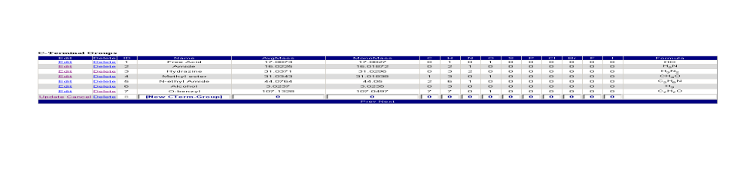
Figure 13 Adding a new C-Terminal Group row

Updating a row

This UpdateCommand event handler does the following:

- Delete the last row ([New Cterm-Group]) from the DataSet Table if it is not the one being updated
- If it was deleted, then the AcceptChanges() is called so there will be no attempt to delete from the table in the database since it really does not exist there.
- Next get the value from each TextBox control and update the corresponding cell in the DataSet Table. Note the TextBox control has index equal zero in the Cells control collection.
- Update the CTerminal Database table with the row changes or new row addition
- Reset the EditItemIndex to –1, Set the DataSource to the modified DataSet and Call DataBind()

Note: if the update does not appear to work even though all of the event handlers are being called, check to see if you are using the IsPostBack method in the Page_OnLoad() event handler. For example

if (!Page.IsPostBack)
dgCTerminalGroups.DataBind();

private void dgCTerminalGroups_UpdateCommand(object source,
System.Web.UI.WebControls.DataGridCommandEventArgs e)
{
DataRow dr;
DataSet ds;
ds = (DataSet)dgCTerminalGroups.DataSource;
DataTable dt = ds.Tables["CTerminal"];

// this code segment simply deletes the blank row at the
// end of the table if it is not the row being modified/updated.
if (e.Item.DataSetIndex < dt.Rows.Count-1)
{
dt.Rows[dt.Rows.Count-1].Delete();
dt.AcceptChanges();
}
dr = dt.Rows[e.Item.DataSetIndex];
for(int i=0; i< dt.Columns.Count; i++)
{
// The TextBox is the 0th element of the Controls collection.
// the edit, delete columns are at cells i=0 and i=1 respectively, skip those
TextBox tbox = (TextBox)e.Item.Cells[i+2].Controls[0];
if (!tbox.ReadOnly) // skip readonly cells; set in PreRender() event handler.
dr[dt.Columns[i].Caption] = tbox.Text;
}

if (ds.HasChanges())
{
DataSet dsChanges = ds.GetChanges();
// call an update database function (code for method not shown)
// merge the changes
// with the DataSet contained by the DataGrid
UpdateTerminalTable(dsChanges, "CTerminal") != null)
ds.Merge(dsChanges);
}

// Switch out of edit mode.
dgCTerminalGroups.EditItemIndex = -1;
dgCTerminalGroups.DataSource=ds;
dgCTerminalGroups.DataBind();

}

Setting Cell Style values

When individual cells in the DataGrid Table need to be formatted beyond global grid and column settings, a user defined DataGrid PreRender event handler can be defined. The following code provides an example of a handler that can be used to set individual cell style values. The result of formatting based upon data types contained in the DataGrid can be seen by comparing Figures 13 and 14. The formatting includes
- setting horizontal alignment properties for all cells
- setting the [New Term Group] row to be in Italic and to have the ForeColor and BackColor properties set to Color.DarkGray and Color.White respectively
- setting the ForeColor and BackColor to Color.DarkBlue and Color.LightGray respectively for decimal numbers.
This is a powerful technique that can be used for example to reflect cell edit changes by changing the individual cell font and colors of a changed cell.

This example further illustrates formatting using HTML CssStyles and control properties in the section of the code where it specifically handles the row currently being edited which is contained in the EditItemIndex member.

Note
In the dg_PreRender code, the for-loop

for (int j=0; j < dg.Items.Count; j++)

the maximum number of Items will be less than or equal to the dg.PageSize. To use j as an index for a table row, j needs to be augmented by dg.PageSize*dg.CurrentPageIndex. For example, column i for Item j in table dt is accessed as

dt.Rows[j + dg.PageSize*dg.CurrentPageIndex][i]

where dg.CurrentPageIndex contains a zero-based index.

private void dg_PreRender(object sender, System.EventArgs e, string strTableName)
{
DataGrid dg = (DataGrid)sender;
DataTable dt = null;
if (dg.DataSource.GetType() == typeof(DataSet))
{
DataSet ds = (DataSet)dg.DataSource;

dt = ds.Tables[strTableName];

}
else
if (dg.DataSource.GetType() == typeof(DataTable))
dt = (DataTable)dg.DataSource;

if (dt != null)
{
for (int j=0; j <dg.Items.Count; j++)
{
if (j == (dg.Items.Count-1) &&
((string)dt.Rows[j+dg.PageSize*dg.CurrentPageIndex]["Name"]).IndexOf("[New") > -1)

bNewGroupRow = true;
else
bNewGroupRow = false;

for(int i=0; i<(dt.Columns.Count); i++)
{
// accentuate [New Term Group] row with font and color modifications
if(bNewGroupRow && dg.EditItemIndex == -1)
{
dg.Items[j].Cells[i+2].ForeColor = Color.DarkGray;
dg.Items[j].Cells[i+2].BackColor = Color.White;
FontInfo fi = dg.Items[j].Cells[i+2].Font;
fi.Italic = true;
}

if(dt.Columns[i].DataType == typeof(System.Guid) ||
dt.Columns[i].DataType == typeof(System.String))
{

dg.Items[j].Cells[i+2].HorizontalAlign = HorizontalAlign.Left ;
dg.Items[j].Cells[i+2].Wrap = true ;

}
else
if(dt.Columns[i].DataType == typeof(System.DateTime))
dg.Items[j].Cells[i+2].HorizontalAlign =HorizontalAlign.Center ;
else
if(dt.Columns[i].DataType == typeof(int))
{
dg.Items[j].Cells[i+2].HorizontalAlign = HorizontalAlign.Center ;
}

else
{
if(dt.Columns[i].DataType == typeof(System.Double)
|| dt.Columns[i].DataType ==typeof(System.Decimal)
|| dt.Columns[i].DataType == typeof(float))
{
dg.Items[j].Cells[i+2].HorizontalAlign =
HorizontalAlign.Right;

// set the text color to DarkBlue and background color
// LightGray
dg.Items[j].Cells[i+2].ForeColor = Color.DarkBlue;
dg.Items[j].Cells[i+2].BackColor = Color.LightGray;

}

}
}
}

// check to see if a row is being edited, if it is then the EditItemIndex member is non-negative
// Each cell in the row now has an edit control, this code gets the EditControl object for
// the cell and then sets its cell specific attributes. This example uses the Caption text as
// a filter to select the cell type and then sets its individual style properties. Two cells
// ID and Forumla are readonly and their text color is set to DarkGray. The example also uses
// CssStyle to set global style attributes for each cell.

if (dg.EditItemIndex > -1)
{
string strCaption;
for(int i=2; i<=(dt.Columns.Count+1); i++)
{
TextBox tbox =
(TextBox)dg.Items[dg.EditItemIndex].Cells[i].Controls[0];
tbox.BackColor = Color.White;
tbox.ForeColor = Color.DarkBlue;
System.Web.UI.AttributeCollection tboxAttributes = tbox.Attributes;
tboxAttributes.CssStyle.Add("font-weight", "bold");
tboxAttributes.CssStyle.Add("text-align", "center");
strCaption = dt.Columns[i-2].Caption.Trim();

if (strCaption == "ID")
{
tbox.ReadOnly = true;
tbox.ForeColor = Color.DarkGray;
tbox.BorderWidth = 0;
tbox.Width = 30;
}
else
if (
strCaption == "C" || strCaption == "H" ||
strCaption == "N" || strCaption == "O" ||
strCaption == "S" || strCaption == "P" ||
strCaption == "Br" || strCaption == "Cl" ||
strCaption == "F" || strCaption == "I"
)
{
tbox.Width = 30;
}
else
if (strCaption == "Formula")
{
tbox.Width = 150;
tbox.ReadOnly = true;
tbox.ForeColor = Color.DarkGray;
tbox.BorderWidth = 0;
tbox.Text = string.Empty;

}
else
if (strCaption == "AvgMass" || strCaption == "MonoMass" )
{
tbox.Width = 75;

}
else
if (strCaption == "Name" )
{
tbox.Width = 150;

}
else

tbox.Width = 75;

}
}
}

}

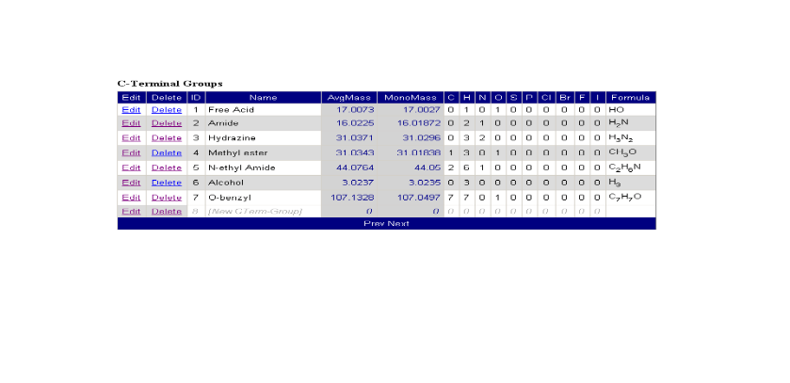
Figure 14 Formatting DataGrid using PreRender method

References

- Microsoft Visual Studio .NET IDE help system
- Microsoft Developer Network online help system
- Programming Microsoft Windows with C#, Charles Petzold, Microsoft Press, 2002.
- ASP.NET Data Web Controls, Scott Mitchell, SAMS, 2003

Appendix

Visual Basic.Net Code Example for FormatDG

Greg Dunn contributed this VB.Net code example.

Public Class DataGridStyler

Shared Sub FormatDataGrid(ByVal pdtgX As DataGrid)
'Purpose........:
' Creates and applies a DataGridTableStyle, sizing columns
' and the grid itself based on the data to be displayed.
'Parameters.....:
' pdtgX The DataGrid to be formatted.
'Author: Pete Smietana
'Last Modified..: 12/24/2003
'Modified By....: Greg Dunn
'Modifications..:
' 1. Translated to Visual Basic
' 2. Made the method Shared (the equivalent of Static in C#), so
' it can be invoked without instantiating an object to do so.
' 3. Adapted it to accomodate the use of a DataTable (as well as
' a DataSet) as the DataGrid's DataSource. Setting the DataSource
' to a DataTable causes the table to be displayed fully opened
' from the outset - generally what you want if the grid is
' displaying data from a non-hierarchical table or view.
' 4. This version causes key columns to be suppressed. However, it
' does this by means highly specific to the data structures used
' for a particular application (which name all key fields with
' a suffix of "_ID". To make the facility more general I would
' probably go to a method based on a lookup table (of columns
' to be excluded, by data table or entity).
' 5. Hard-coded constants were converted to Constants.
' Additional constants were defined to solve minor sizing
' problems; e.g., intWHITE_SPACE_HORIZ, intROW_WIDTH_BUFFER,
' intWHITE_SPACE_VERT.
' 6. The constant blnALLOW_SORTING was created to back that
' hard-coded setting out of the code. There are probably other
' properties which are candidates for similar treatment.
' 7. The datatype tests on DataTableColumns were accomplished
' by comparing the string version of the reported datatype, rather
' than comparing datatypes directly. For some reason I could not
' find a direct type comparison that worked properly in Visual Basic
' for these particular items. I am able to check the type of the
' incoming parameter directly, however, as follows:
'
' If TypeOf pdtgX.DataSource Is DataTable Then
' tblX = CType(pdtgX.DataSource, DataTable)
' dstX = tblX.DataSet
' ElseIf TypeOf pdtgX.DataSource Is DataSet Then
' dstX = CType(pdtgX.DataSource, DataSet)
' End If
'
' I am also able to check the data type of table data directly:
'
' If TypeOf dtrX(intCol).GetType Is System.String _
' And strTemp.Length > intMAXCOLWIDTH Then
'
' I'm not sure why the DataTableColumn types are exceptional.
'
' 8. I changed most of the variable names, simply to reflect
' personal preferences in naming conventions.
'
' 9. I added new comments and expanded many existing ones as part
' of my own learning experience.
'
' 10. I converted the datatype of widths to singles, as the "float"
' type is not supported in VB.
'
' 11. For datetime columns, I am basing the size on the date part of the
' value only (rather than the date and time parts), since that is
' the default format for display of the dates.

'Desired Further Mods..:
' 1. I would like all column headers centered (but haven't figured
' out how to center the header without also centering the data).

Const intMAXCOLWIDTH As Int16 = 200
Const intSCROLL_BAR_WIDTH As Int16 = 16
Const intWHITE_SPACE_HORIZ As Int16 = 20
'The following constant keeps the right edge of the datagrid
'from overrunning the space provided for it.
Const intROW_WIDTH_BUFFER As Int16 = 5
Const intWHITE_SPACE_VERT As Int16 = 50
Const intWIDTH_COLUMN_BOOLEAN As Int16 = 50
Const blnALLOW_SORTING As Boolean = True

Dim colBackColorAlternating As System.Drawing.Color = Color.BlanchedAlmond
Dim strDataType As String
Dim strColName As String
Dim dstX As DataSet
Dim tblX As DataTable
Dim strColNameSuffix As String

If TypeOf pdtgX.DataSource Is DataTable Then
tblX = CType(pdtgX.DataSource, DataTable)
dstX = tblX.DataSet
ElseIf TypeOf pdtgX.DataSource Is DataSet Then
dstX = CType(pdtgX.DataSource, DataSet)
End If

If Not IsDBNull(dstX) Then
If pdtgX.TableStyles.Count > 0 Then
pdtgX.TableStyles.Clear()
End If

Dim sglDataGridWidth_Proposed As Single = 0.0
Dim intMaxHeight As Int16 = 0
Dim intDataGridHeight_Proposed As Int16 = 0

For Each tblX In dstX.Tables
Dim dgsX As DataGridTableStyle = New DataGridTableStyle
dgsX.MappingName = tblX.TableName
dgsX.AllowSorting = blnALLOW_SORTING
dgsX.AlternatingBackColor = colBackColorAlternating

Dim dgcColumnTextbox As DataGridTextBoxColumn
Dim intNumberOfColumns As Int16 = tblX.Columns.Count
Dim dtrX As DataRow
Dim alColumnWidths As New ArrayList
Dim objGraphics As Graphics = pdtgX.CreateGraphics
Dim objFont As Font = pdtgX.Font
Dim objFontSize As SizeF

'Store widths for each column header to the
'alColumnwidths arraylist.
Dim dtcX As DataColumn
For Each dtcX In tblX.Columns
objFontSize = objGraphics.MeasureString("W" + dtcX.Caption, objFont)
alColumnWidths.Add(objFontSize.Width)
Next

'Check the data in each column of each row, comparing the
'size required to display that value against the column width
'previously set for the column.
'The initial width for the column is based on the width
'of the column header.

Dim intRow As Int16
Dim intCol As Int16
Dim strTemp As String

For intRow = 0 To tblX.Rows.Count - 1
dtrX = tblX.Rows(intRow)
For intCol = 0 To intNumberOfColumns - 1
'If the column is null-valued, we won't be
'changing it's width!
If Not Convert.IsDBNull(dtrX(intCol)) Then
strColName = tblX.Columns(intCol).ColumnName
If dtrX(intCol).GetType.ToString = "System.DateTime" Then
strTemp = dtrX(intCol).ToString

'The following three statements all do the same
'thing: they trim the time of day information
'off the end of the datetime value, leaving
'only a string like '12/31/1999'
'
'strTemp = Left(strTemp, InStr(strTemp, " ") - 1)
'strTemp = Left(strTemp, strTemp.IndexOf(" ") - 1)

'I think this is the form more likely to be
'supported also in C#
strTemp = strTemp.Substring(0, strTemp.IndexOf(" "))

Else
strTemp = dtrX(intCol).ToString
End If
'Regardless of the length of the contained
'values, limit the column with to a maximum
'of intMAXCOLWIDTH characters.
'
'We'll use the width of the character "W" as a pad.

If TypeOf dtrX(intCol).GetType Is System.String _
And strTemp.Length > intMAXCOLWIDTH Then
objFontSize = objGraphics.MeasureString("W" + _
strTemp.Substring(0, intMAXCOLWIDTH - 1), _
objFont)
Else
objFontSize = objGraphics.MeasureString("W" + strTemp, objFont)
End If

'If the data in the current row requires more space
'to display than the column width currently proposed,
'change the proposed column width to the size
'required for the data.

If (objFontSize.Width > _
CType(alColumnWidths(intCol), Single)) Then
alColumnWidths(intCol) = objFontSize.Width
End If
End If
Next 'For intCol = 0 To intNumberOfColumns - 1
Next 'For intRow = 0 To tblX.Rows.Count - 1

'Now we know what column widths we want for every column.
'Time to implement them.
'
'(1) Set each column width to the value determined for
' the column.
'(2) Set the alignment for each column according
' to the data type it contains.
'(3) Set the format for decimal numbers.

Dim sglSumOfWidthsCurrentRow As Single = 0.0
For Each dtcX In tblX.Columns
If TypeOf dtcX.DataType Is Boolean Then
Dim dgcColumnBoolean As New DataGridBoolColumn
dgcColumnBoolean.MappingName = dtcX.ColumnName
dgcColumnBoolean.HeaderText = dtcX.Caption
dgcColumnBoolean.Width = intWIDTH_COLUMN_BOOLEAN
dgcColumnBoolean.ReadOnly = False
dgcColumnBoolean.Alignment = HorizontalAlignment.Center
dgsX.GridColumnStyles.Add(dgcColumnBoolean)
sglSumOfWidthsCurrentRow += dgcColumnBoolean.Width
Else
dgcColumnTextbox = New DataGridTextBoxColumn
dgcColumnTextbox.MappingName = dtcX.ColumnName
dgcColumnTextbox.HeaderText = dtcX.Caption
dgcColumnTextbox.ReadOnly = False
dgcColumnTextbox.NullText = String.Empty

'Neither of the following two methods of type comparison
'work properly...
'
'If TypeOf dtcX.DataType Is System.String Then
'If TypeOf dtcX.DataType.GetType Is System.String Then
'
'...so I'm using this:
'
'If dtcX.DataType.ToString = "System.String" Then

strDataType = dtcX.DataType.ToString
If strDataType = "System.Guid" Or _
strDataType = "System.String" Then
dgcColumnTextbox.Alignment = HorizontalAlignment.Left
ElseIf strDataType = "System.DateTime" Then
dgcColumnTextbox.Alignment = HorizontalAlignment.Center
ElseIf strDataType = "System.Int32" Or _
strDataType = "System.Int16" Then
dgcColumnTextbox.Alignment = HorizontalAlignment.Center
Else
dgcColumnTextbox.Alignment = HorizontalAlignment.Right
If strDataType = "System.single" Or _
strDataType = "System.Single" Or _
strDataType = "System.Decimal" Then
dgcColumnTextbox.Format = "0.00"
End If
End If

dgcColumnTextbox.Width = CInt(alColumnWidths(dtcX.Ordinal))

strColNameSuffix = LCase(Right(dtcX.ColumnName, 3))
If strColNameSuffix = "_id" Then
dgcColumnTextbox.Width = 0
End If
dgsX.GridColumnStyles.Add(dgcColumnTextbox)
sglSumOfWidthsCurrentRow += dgcColumnTextbox.Width
If intMaxHeight < dgcColumnTextbox.TextBox.Height Then
intMaxHeight = dgcColumnTextbox.TextBox.Height
End If
End If
Next 'dtcX In tblX.Columns

pdtgX.TableStyles.Add(dgsX)
'Adjust width of DataGrid to match calculated widths
'select maximum width of all tables in the dataset
'Adjust width to fit inside the parent container’s width

If sglDataGridWidth_Proposed < sglSumOfWidthsCurrentRow Then
sglDataGridWidth_Proposed = sglSumOfWidthsCurrentRow + _
intROW_WIDTH_BUFFER

'I don't understand what the RowHeaderWidth is, exactly;
'or why we're adding it here. - gtd
sglDataGridWidth_Proposed += pdtgX.RowHeaderWidth

'If there are more rows of data to display than
'the datagrid will accomodate, we'll need to leave
'room for a vertical scroll bar.
If pdtgX.VisibleRowCount < tblX.Rows.Count Then
sglDataGridWidth_Proposed += intSCROLL_BAR_WIDTH
'Check to see if the proposed datagrid width is
'greater than the width of its parent; e.g.,
'a panel or tabpage control.
If sglDataGridWidth_Proposed > _
CType(pdtgX.Parent.Width, Single) Then
'Reduce the proposed width of the datagrid
'to what will fit in the parent control, allowing
'room for the scroll bar and a little padding.
sglDataGridWidth_Proposed = _
CType _
(pdtgX.Parent.Width - _
intSCROLL_BAR_WIDTH - _
intWHITE_SPACE_HORIZ, Single)
End If
End If
End If

'---------------------------------------------
'Seems like the logic in the following section is fouled
'up - gtd
'---------------------------------------------
'Adjust the height of DataGrid based upon row visiblity
If pdtgX.VisibleRowCount >= tblX.Rows.Count Then
intDataGridHeight_Proposed = pdtgX.VisibleRowCount * intMaxHeight + _
2 * pdtgX.PreferredRowHeight + intSCROLL_BAR_WIDTH
Else
intDataGridHeight_Proposed = tblX.Rows.Count * intMaxHeight + _
2 * pdtgX.PreferredRowHeight + intSCROLL_BAR_WIDTH
'Make a correction since all rows will now be visible
If intDataGridHeight_Proposed < pdtgX.Parent.Height Then
sglDataGridWidth_Proposed -= intSCROLL_BAR_WIDTH
End If
End If

If intDataGridHeight_Proposed >= pdtgX.Parent.Height Then
'Keep it inside the parent container, with a
'buffer of white space.
intDataGridHeight_Proposed = pdtgX.Parent.Height - pdtgX.Top - intWHITE_SPACE_VERT
End If

pdtgX.Size = New Size(CInt(sglDataGridWidth_Proposed), intDataGridHeight_Proposed)
Next 'For Each tblX In dstX.Tables

End If 'If Not IsDBNull(dstX)

End Sub

End Class

